

Data Base Systems Final Semester Project

Instructor: Rana Rashad Mahmood Khan
Semester : 2nd
Date of submission : 08-06-2026

Group Members:
- Imama Mazhar ( 2025-IST-18)

- Mahnoor Fatima ( 2025-IST-21)

- Muhammad Ibrahim Amjad (2025-IST-32)

- Muhammad Sami ( 2025-IST-49)

Event Management System

Introduction
The Event Management System is a database-based desktop application developed using C#, Windows Forms, and SQL Server. The system helps administrators manage events, bookings, payments, customers, vendors, and venues efficiently.
The project provides CRUD operations (Create, Read, Update, Delete) with a connected SQL Server database and a user-friendly graphical interface.

Objectives
- To manage event information efficiently
- To maintain customer booking records
- To manage vendor details
- To handle payment information
- To generate reports and statistics
- To implement database relationships using SQL Server

Creating Database:
Create database EventManagementSystem:
Created Tables
Created views
Inserted Dummy data
CCreated views,stored procedures Triggers:
Screenshot in SSMS:
Left panel showing all views,Created database and columns
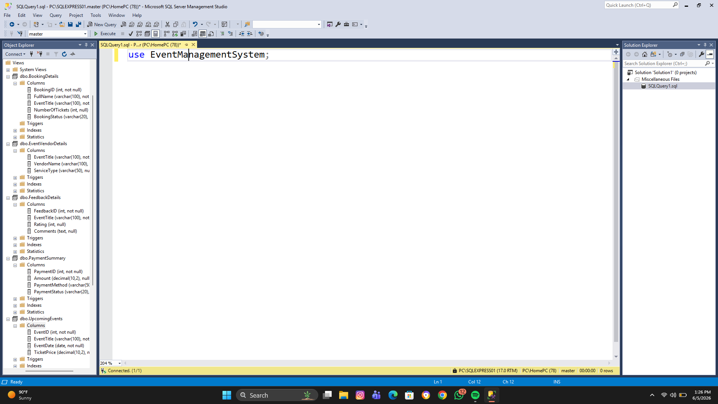

Views:

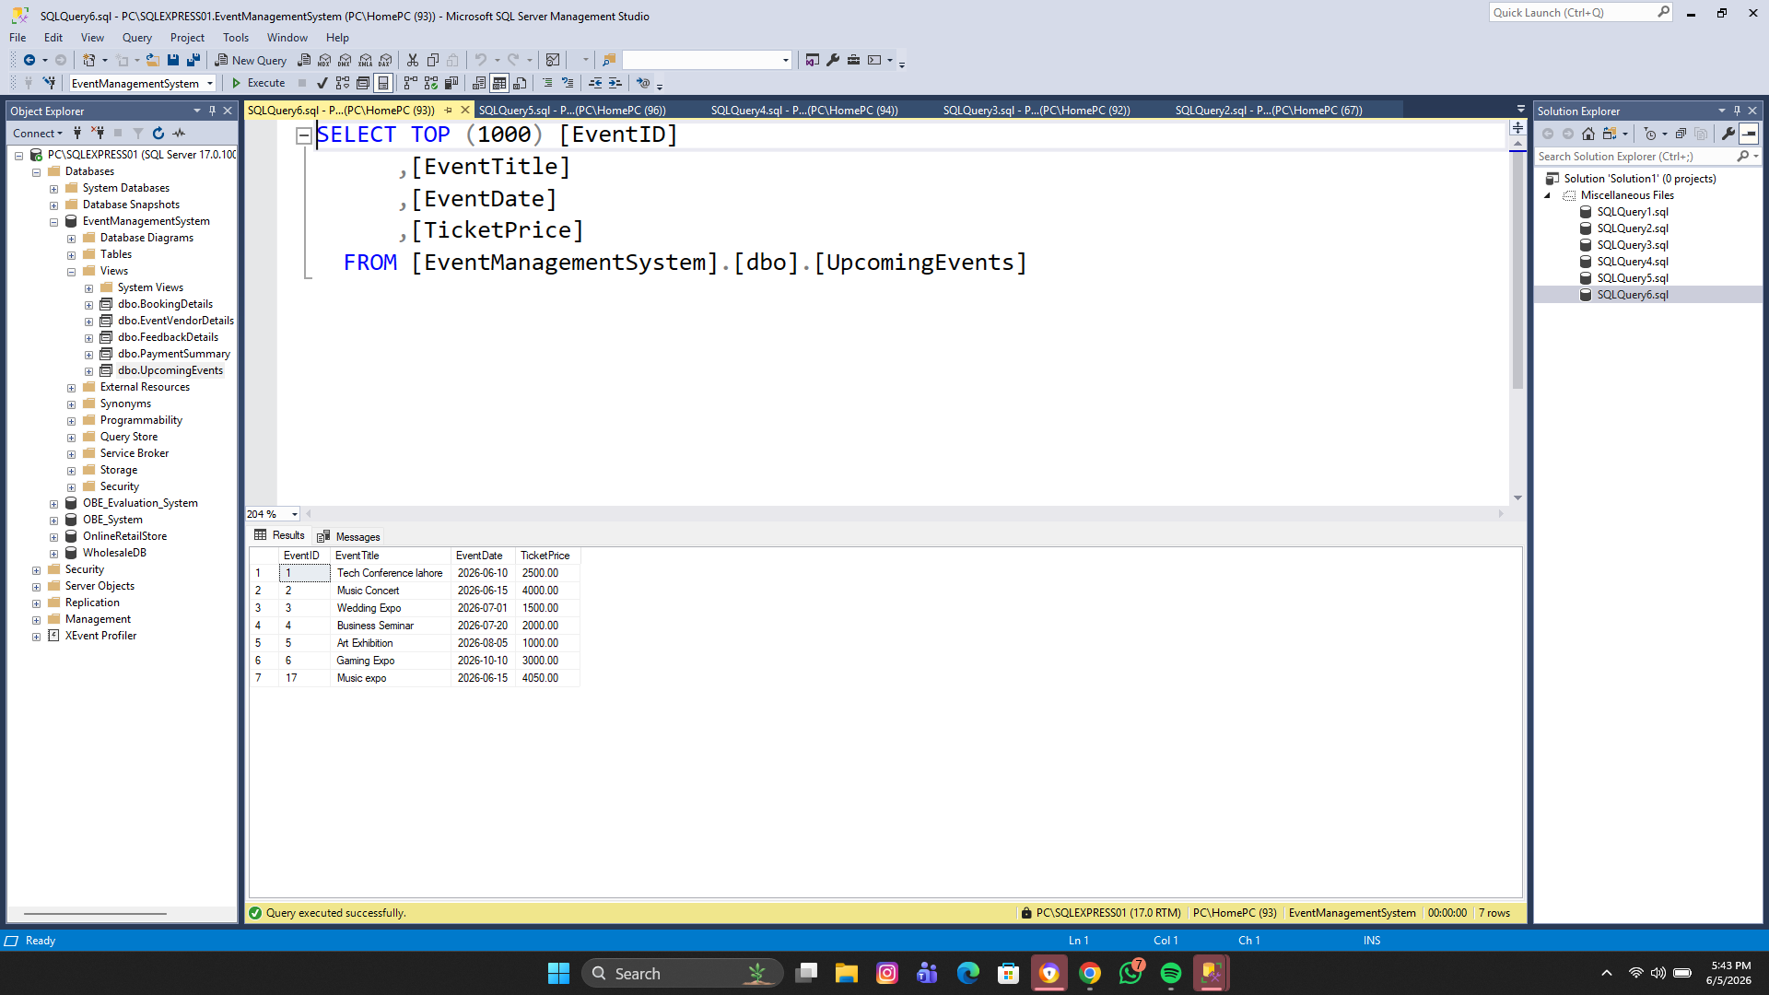

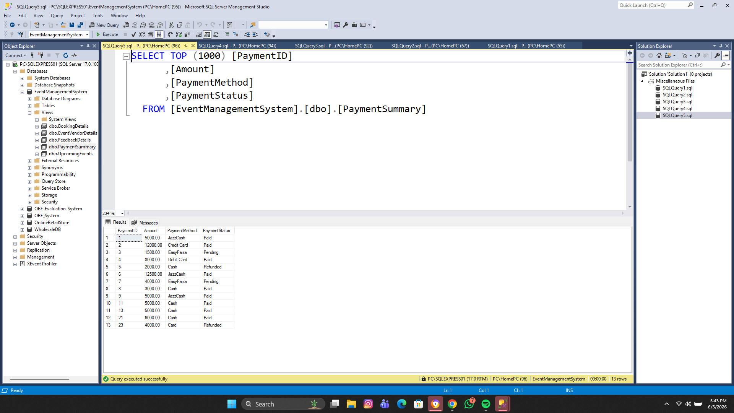
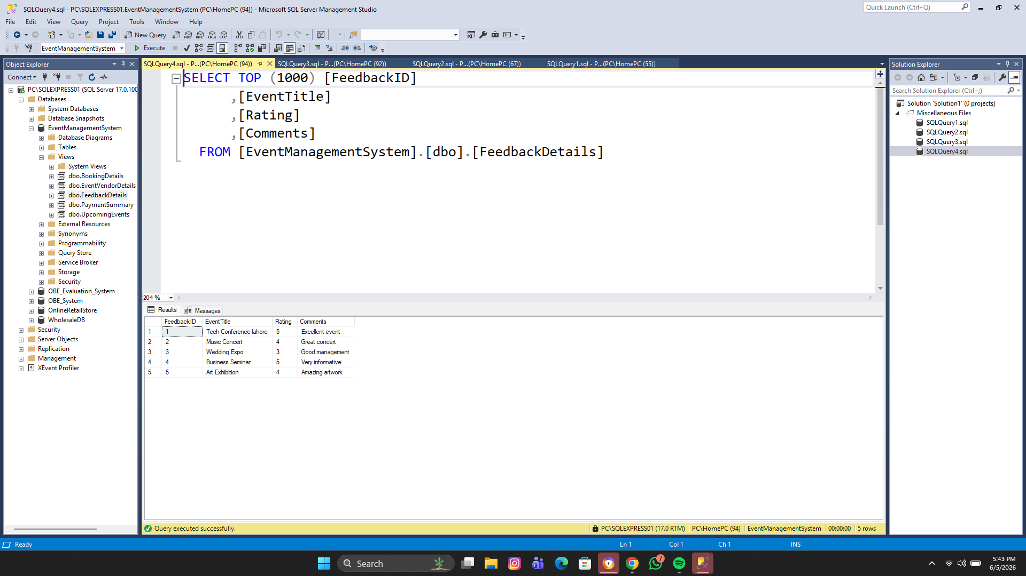
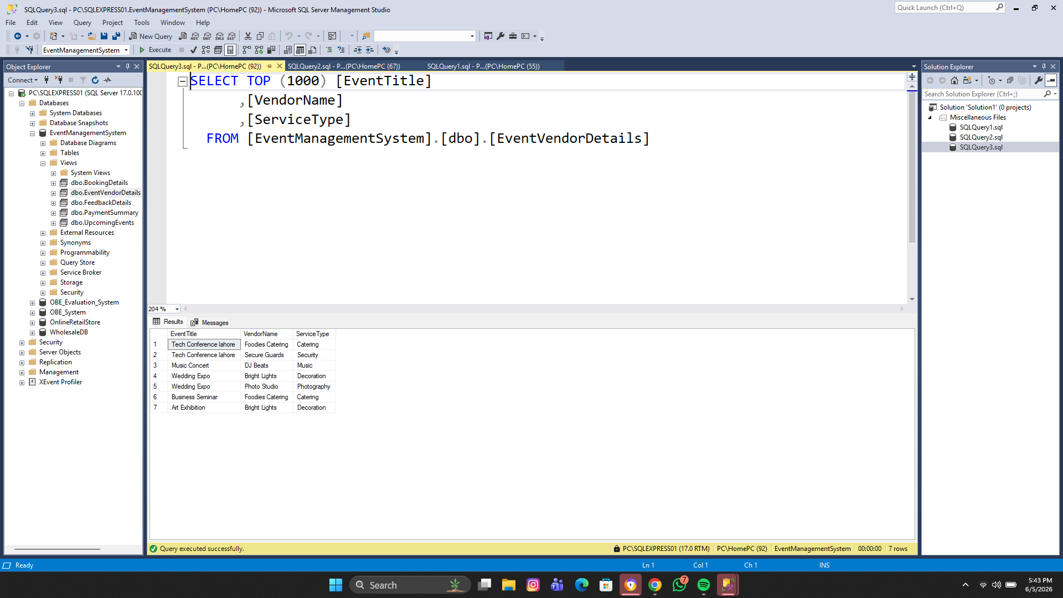
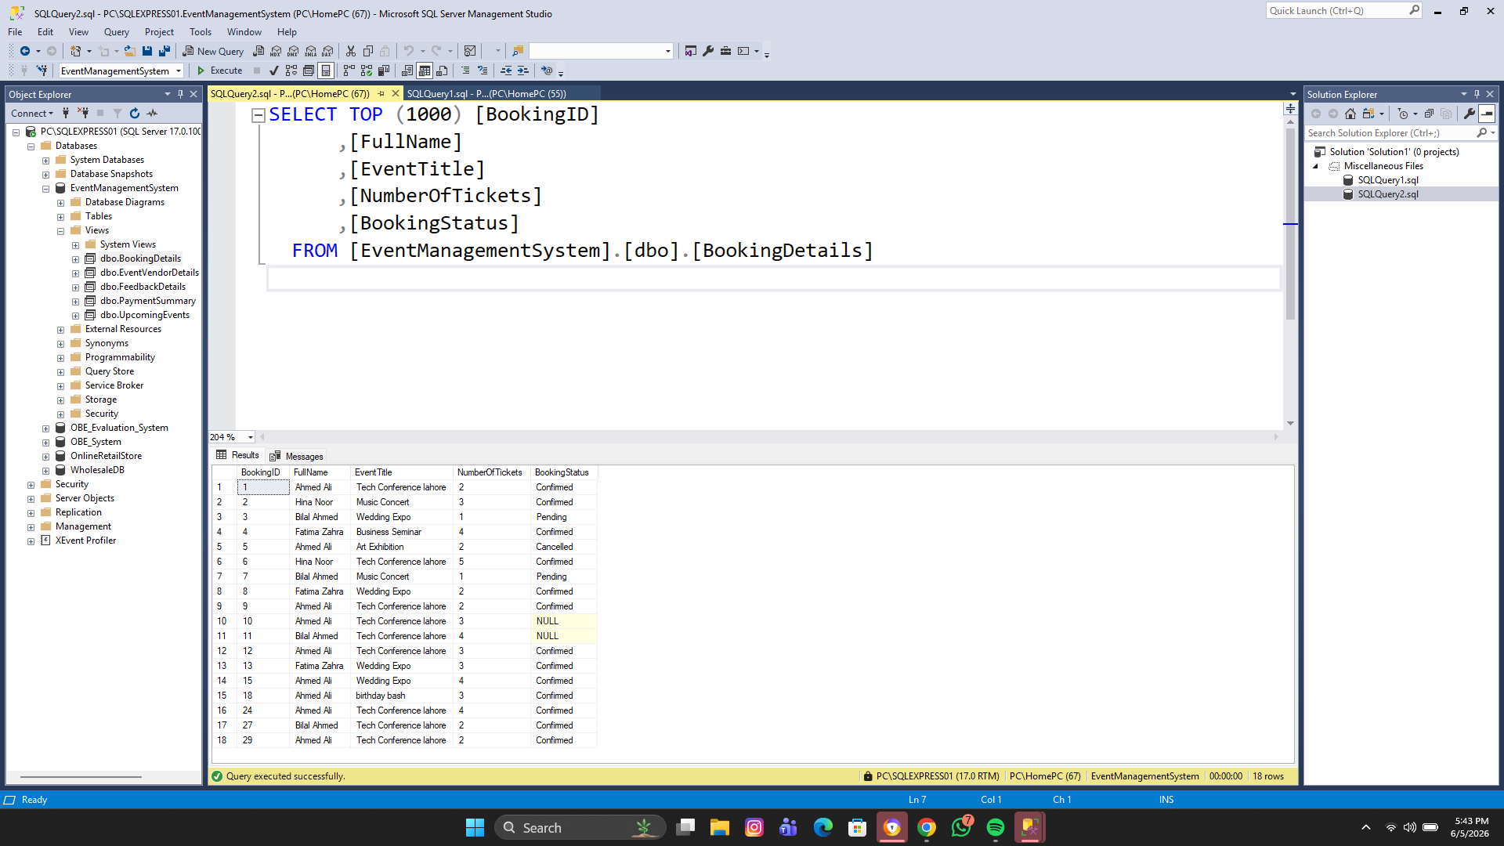
Stored Procedures,Views and Tables:

Tables: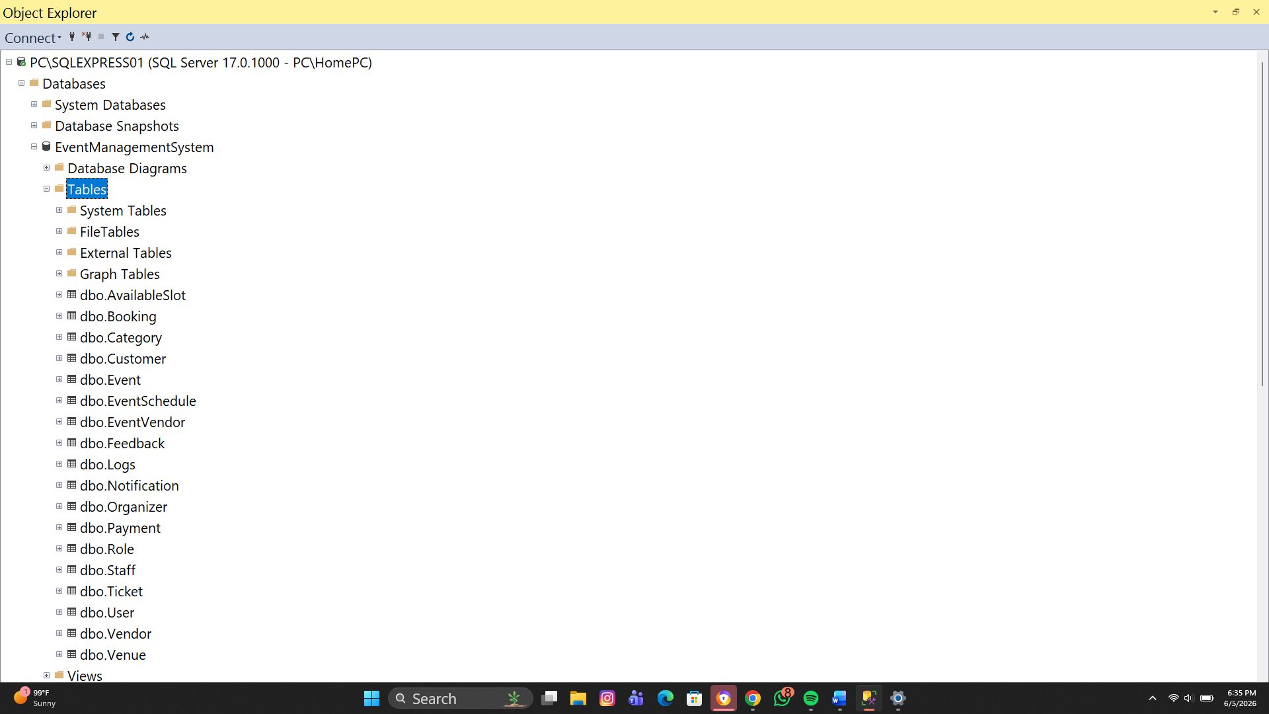
Views and Procedure:
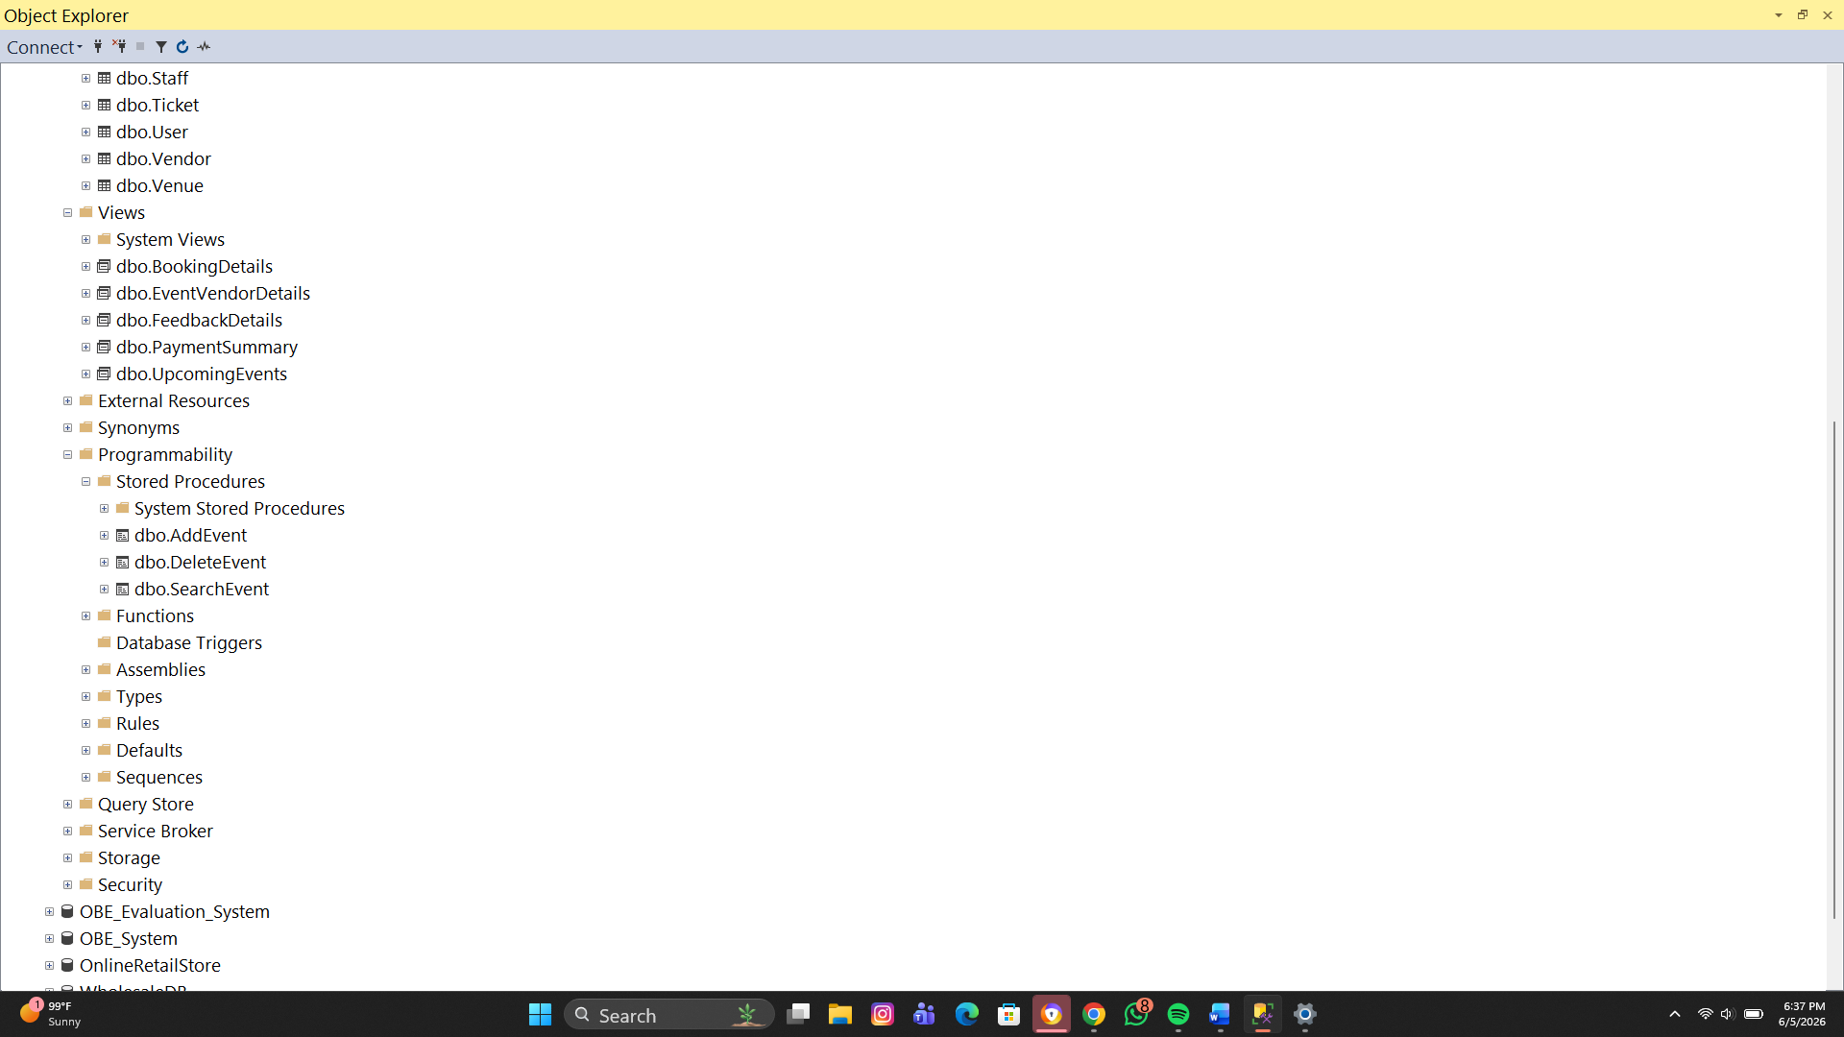

Technologies Used
Frontend
C# Windows Forms (.NET Framework)
Backend
SQL Server
IDE
Microsoft Visual Studio
Database Tool
SQL Server Management Studio (SSMS)

Domain Classes
- User
- Events
- Customer
- Payment
- Booking
- Venues
- Vendors
- Report
- Logs
Software Classes
- DBConnection.cs

- ValidationHelper.cs

- ExceptionLogger.cs

- SessionManager.cs

- ReportManager.cs

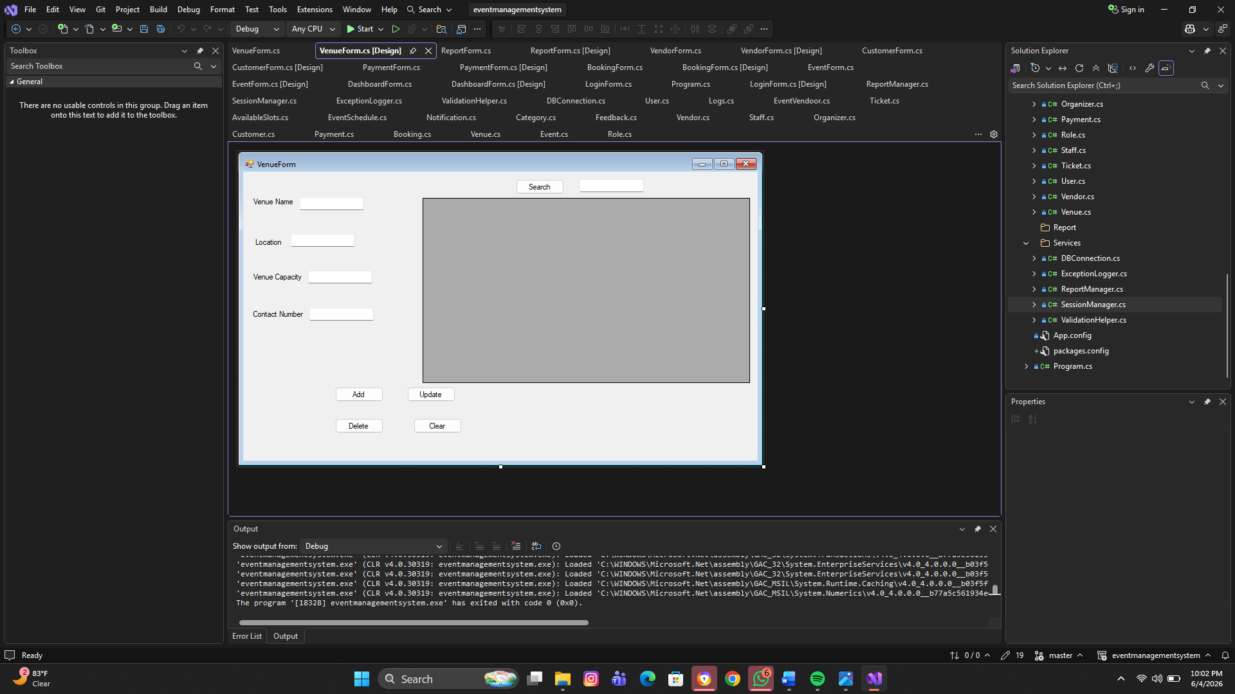

UI Sketch:

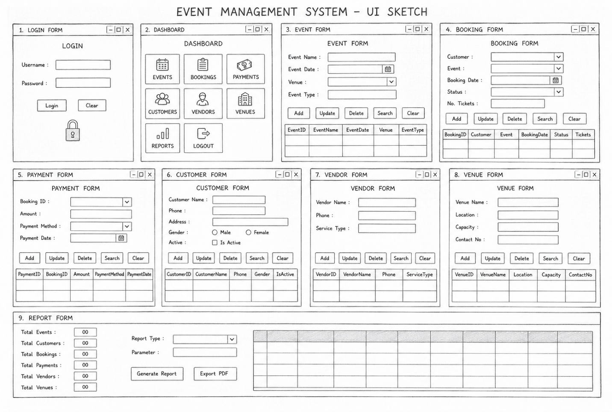

ER-Diagram:
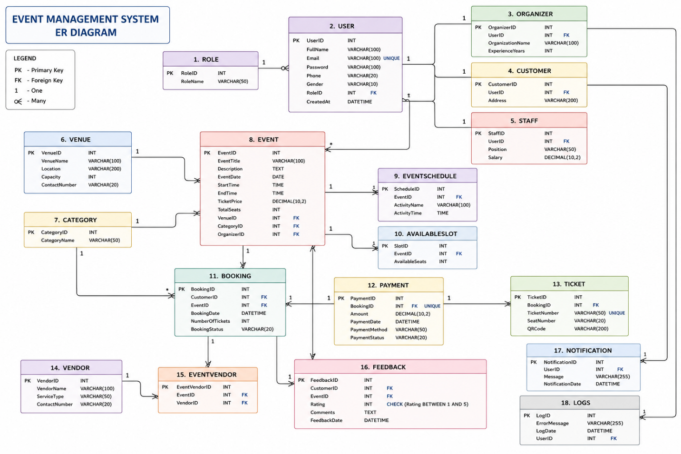

Modules of the System
Login Module
Features:
- Admin login authentication
- Password verification
- Dashboard redirection
- Logout functionality

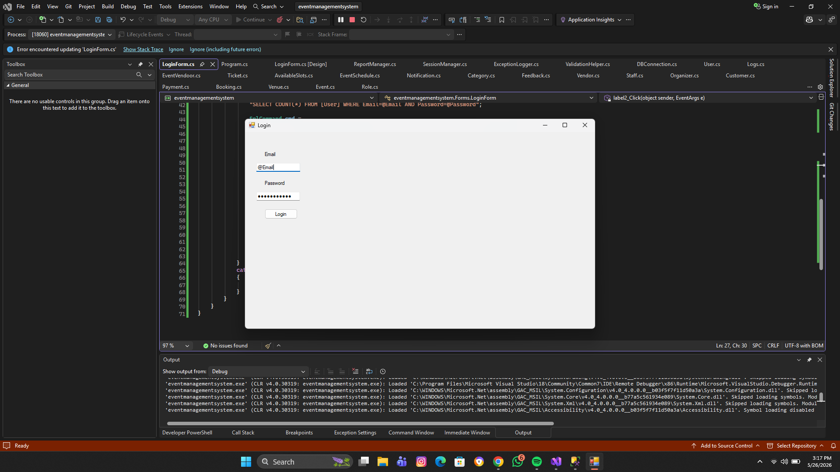
When Wrong or Invalid info added: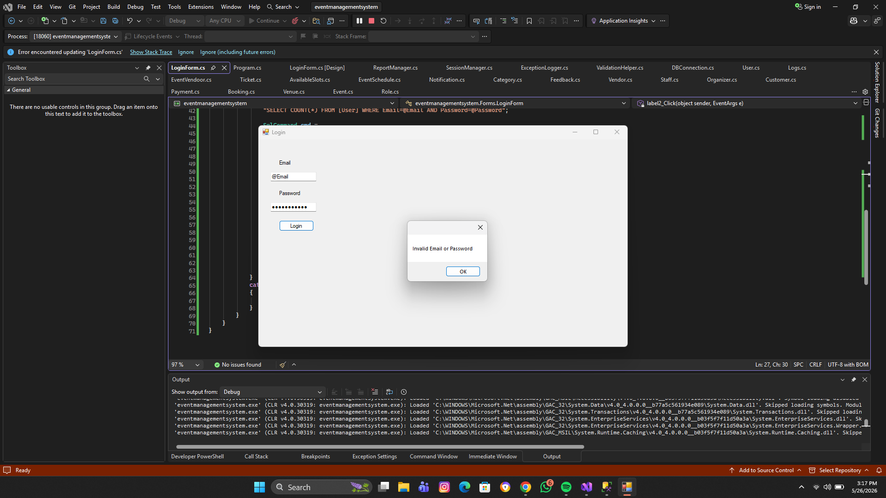
Correct Login info:

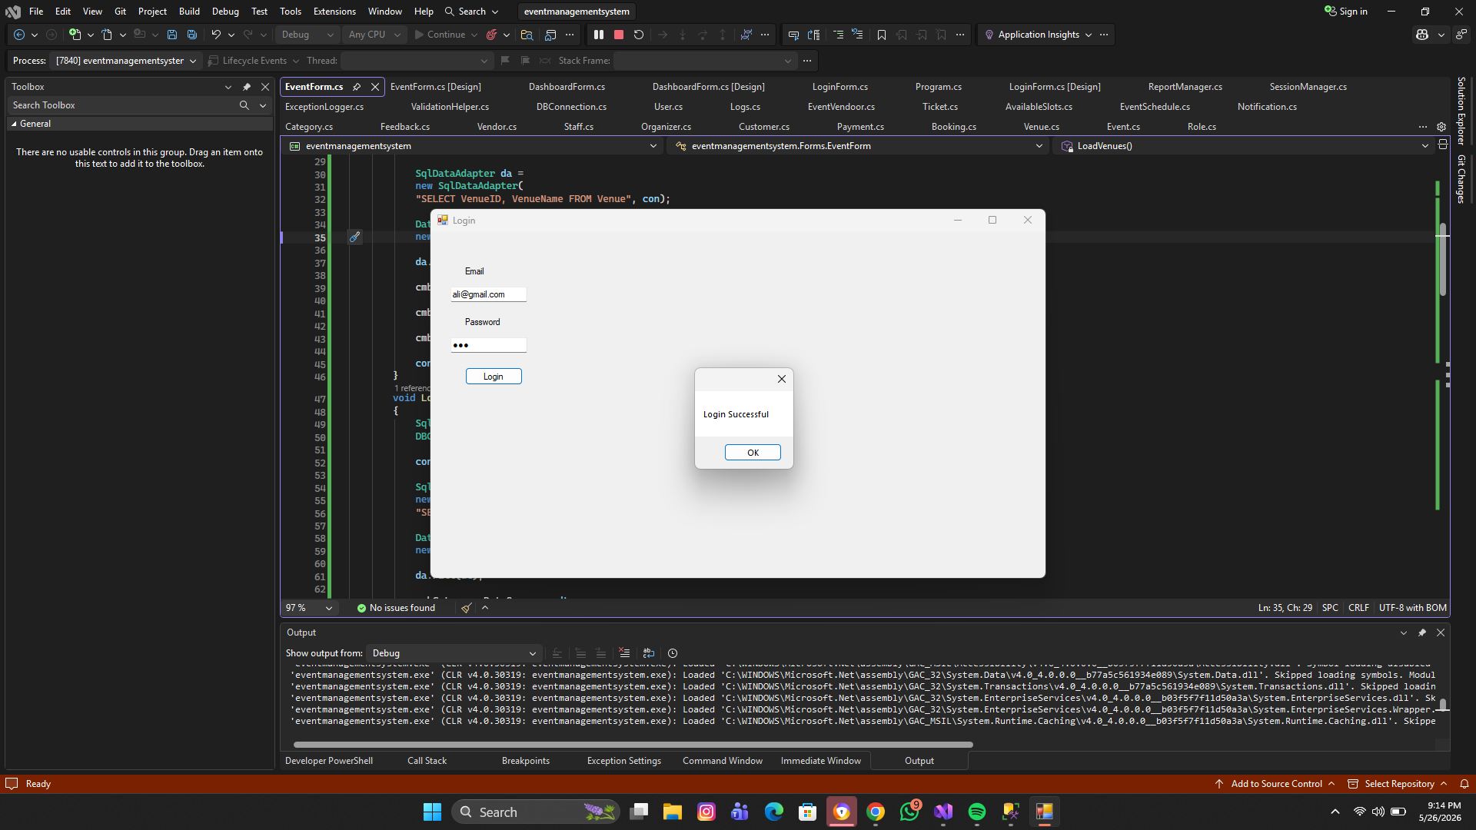
Dashboard Module
Features:
- Navigation between modules
- Reports access
- Statistics display
- File menu
- Panels for UI design

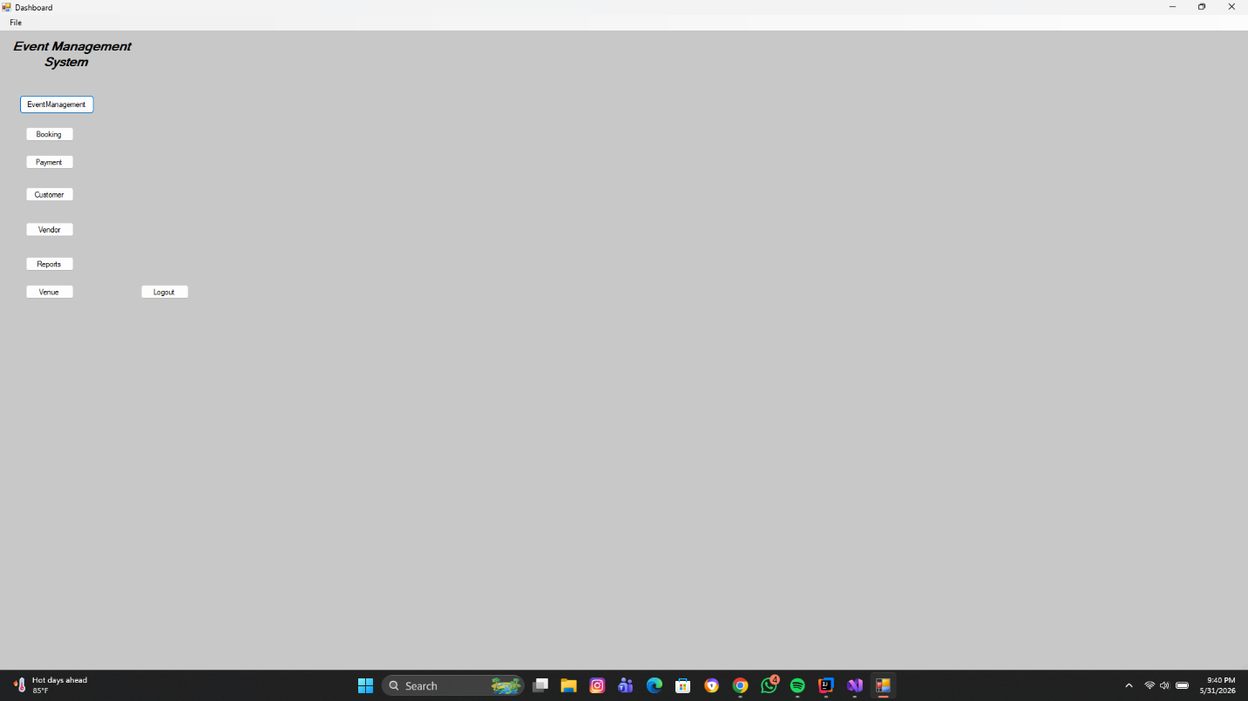
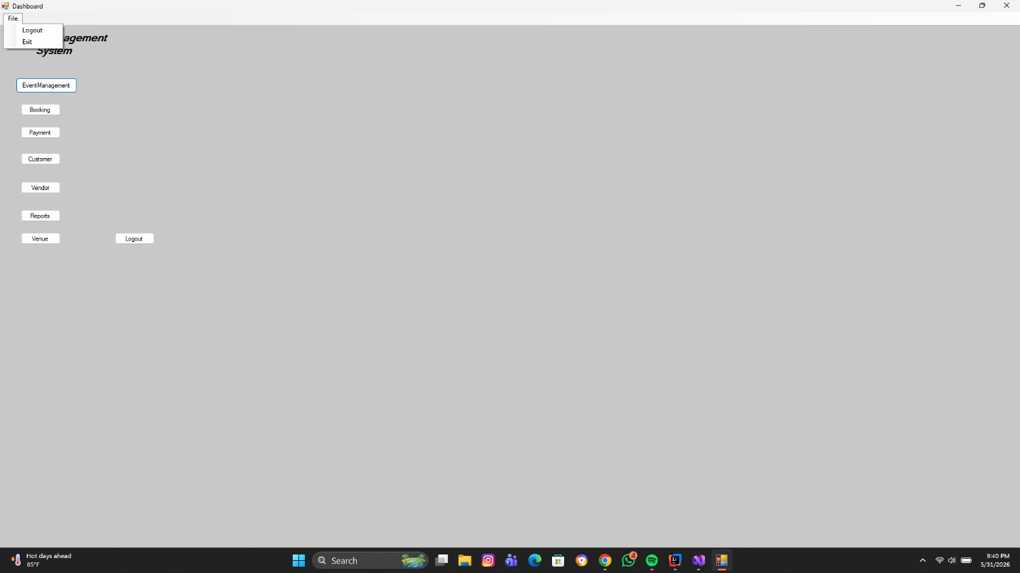
Event Module
Features:
- Add event
- Update event
- Delete event
- Search event
- Display event records
Possible event information:
- Event Name
- Event Date
- Venue
- Seats
- Ticket Price

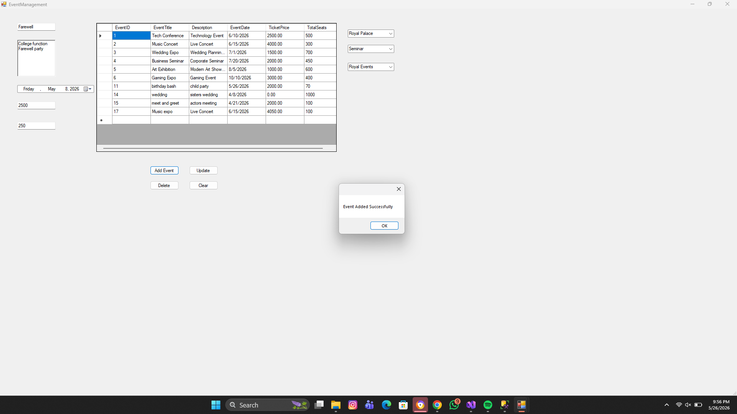
Adding Event:

Updating event:
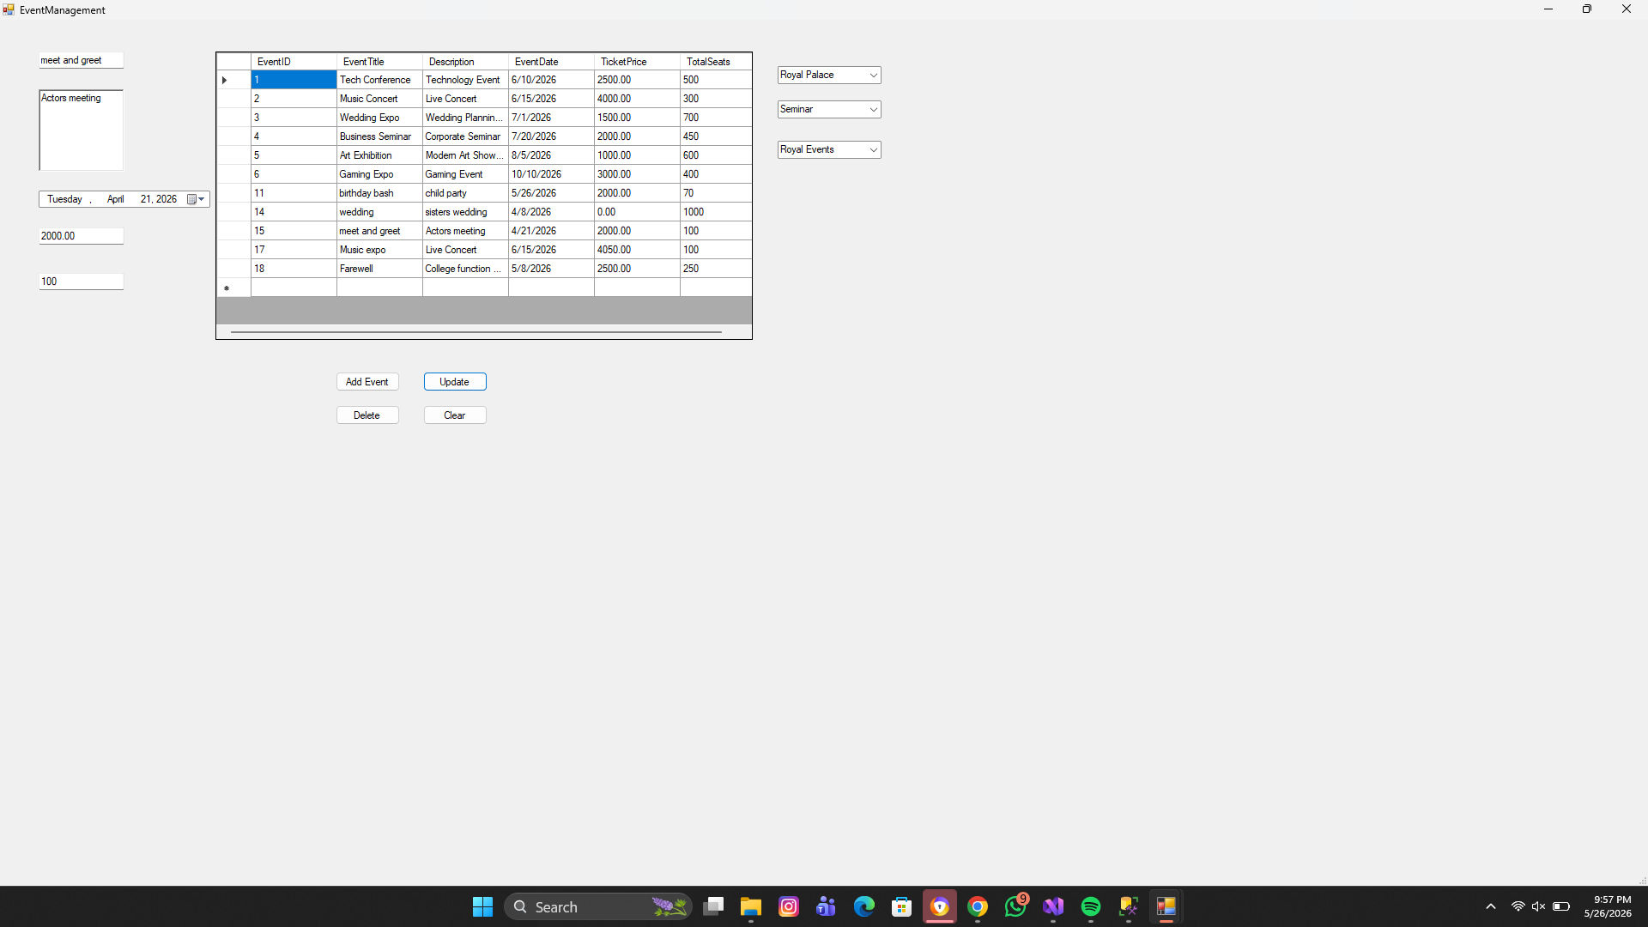
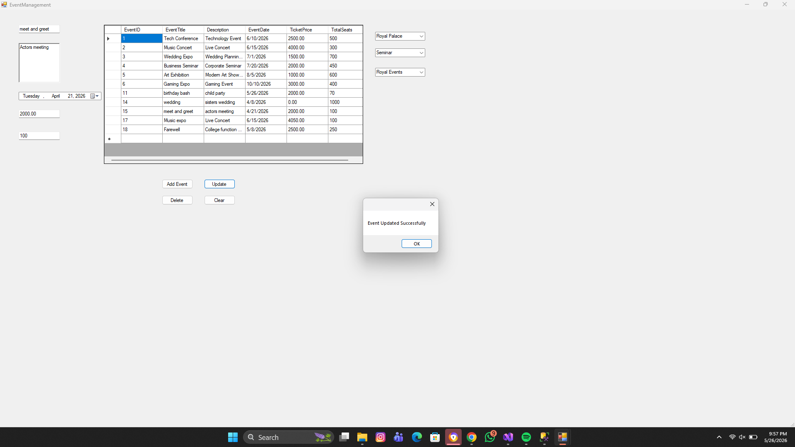

Deleting Event:
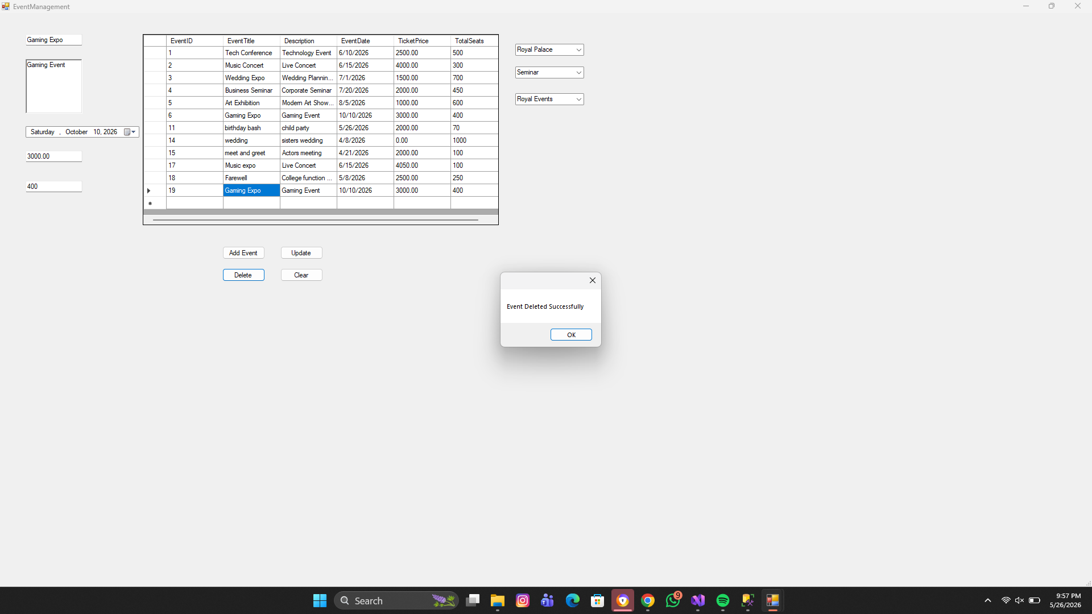
Validation:
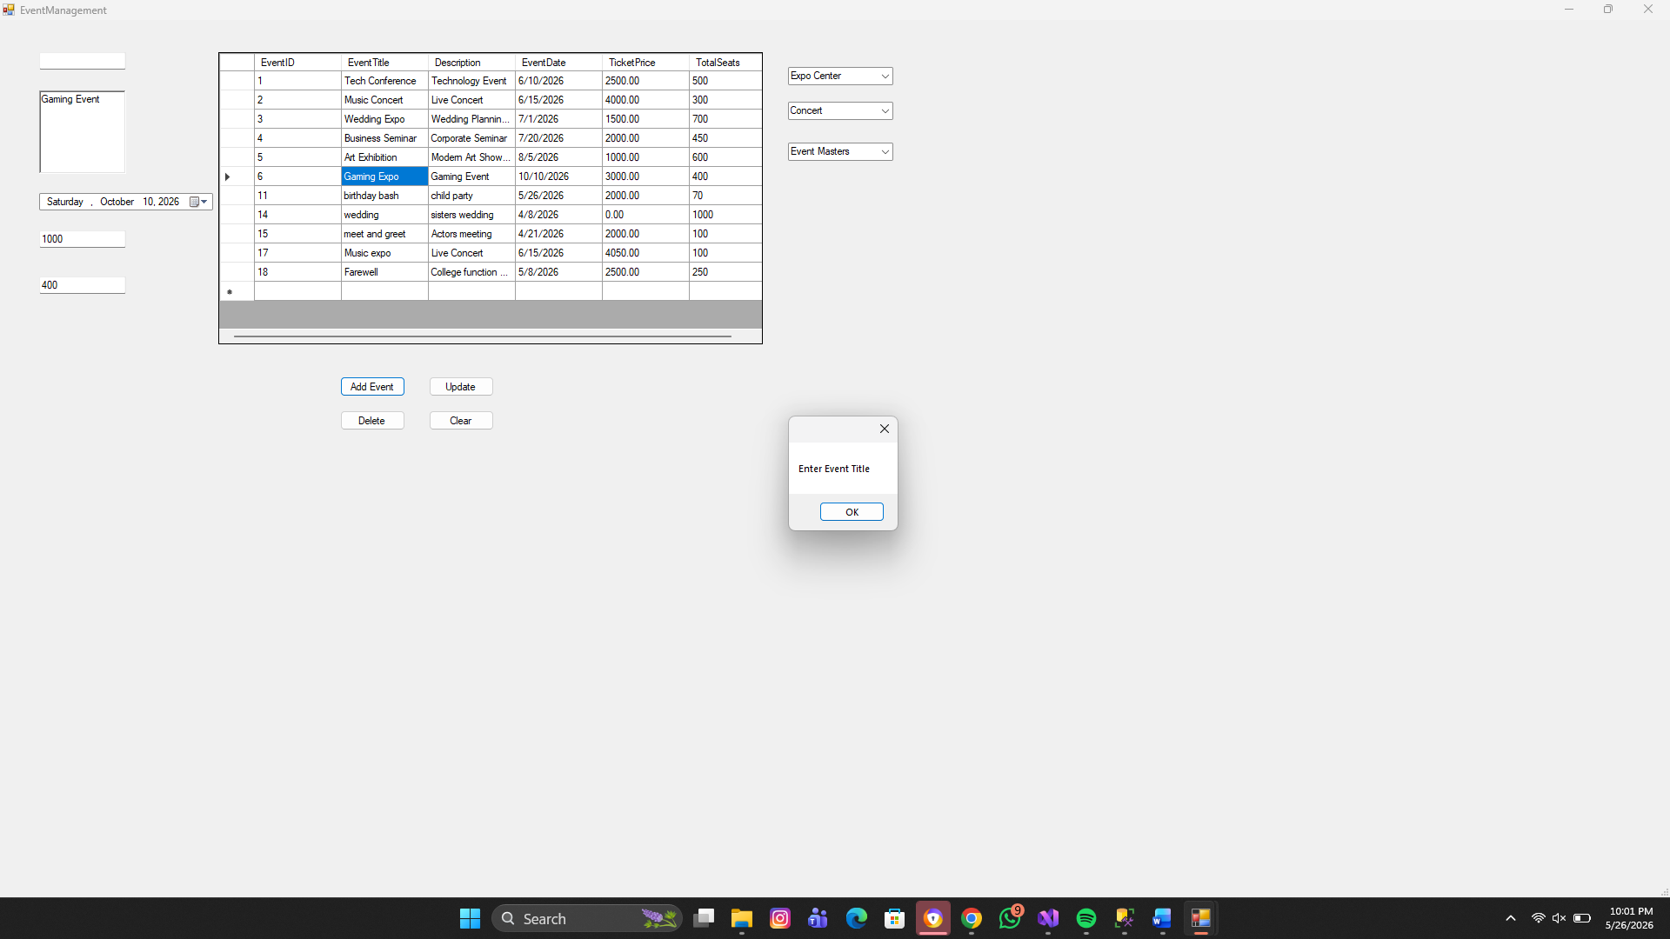
On empty text field:

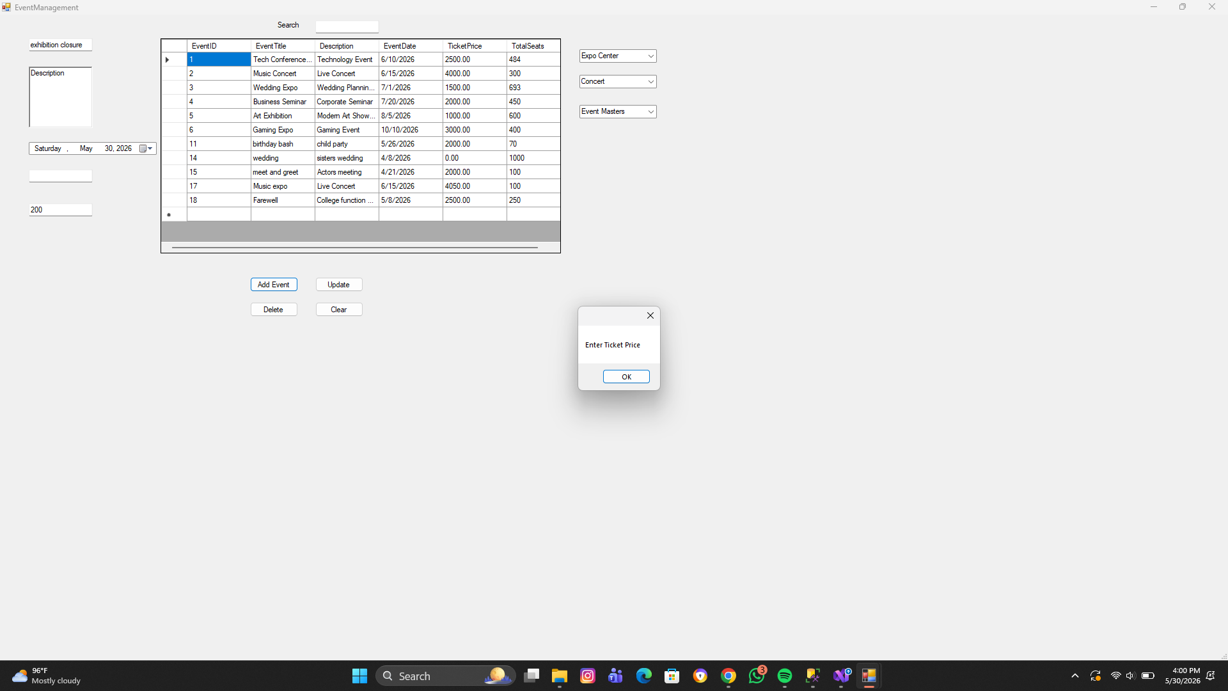

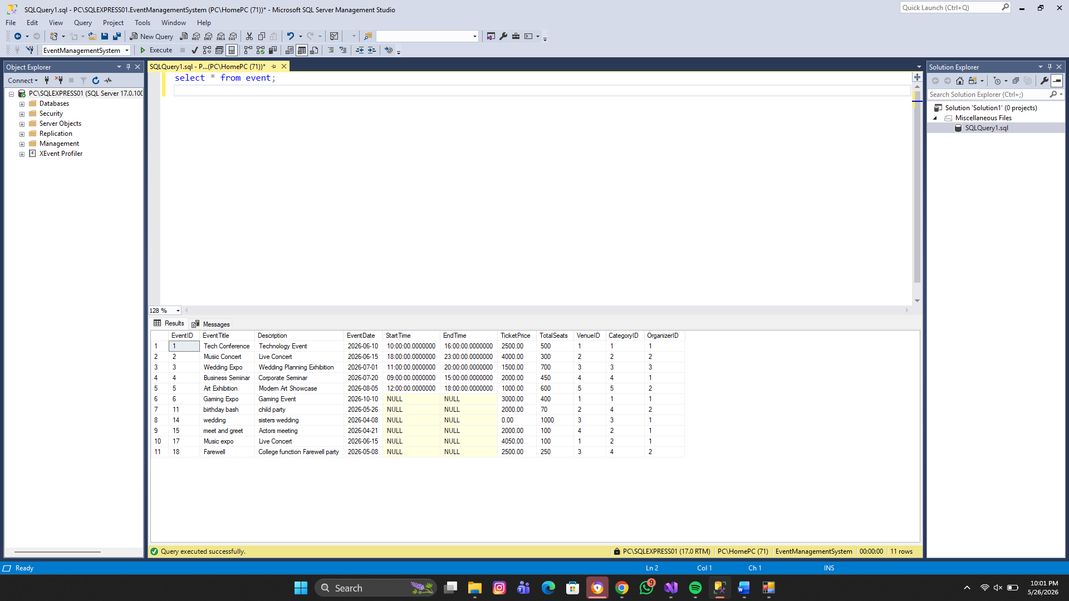
Updated on SSMS:

Booking Module
Features:
- Add booking
- Update booking
- Delete booking
- Search booking
- Booking status handling

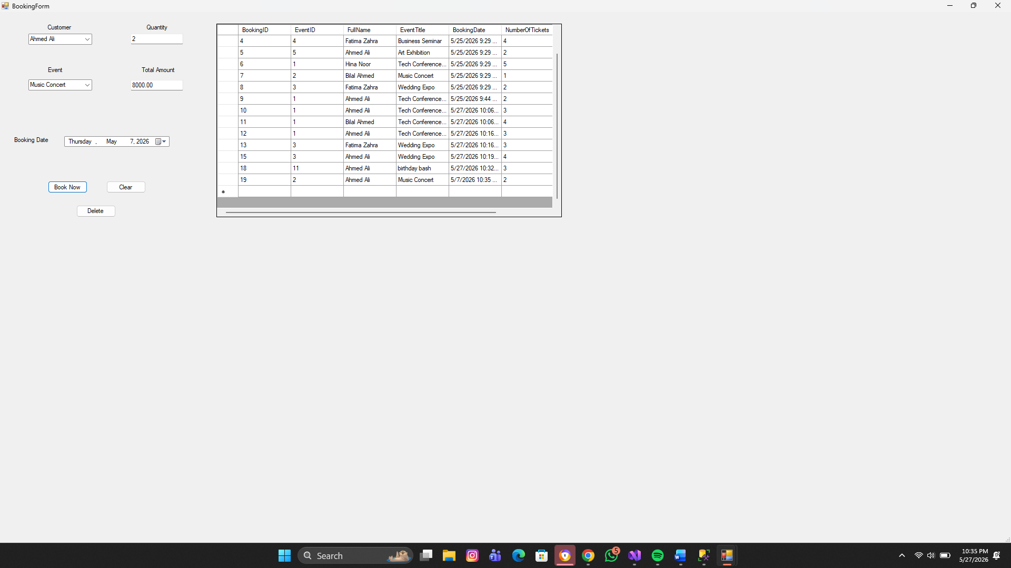
Adding booking:
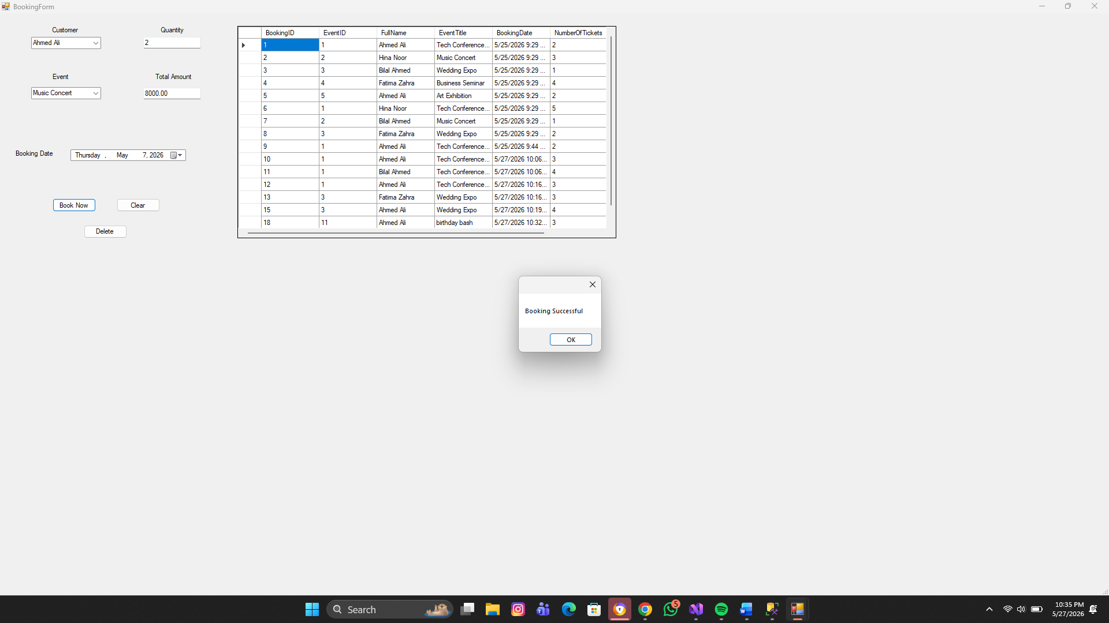

Deleting booking:
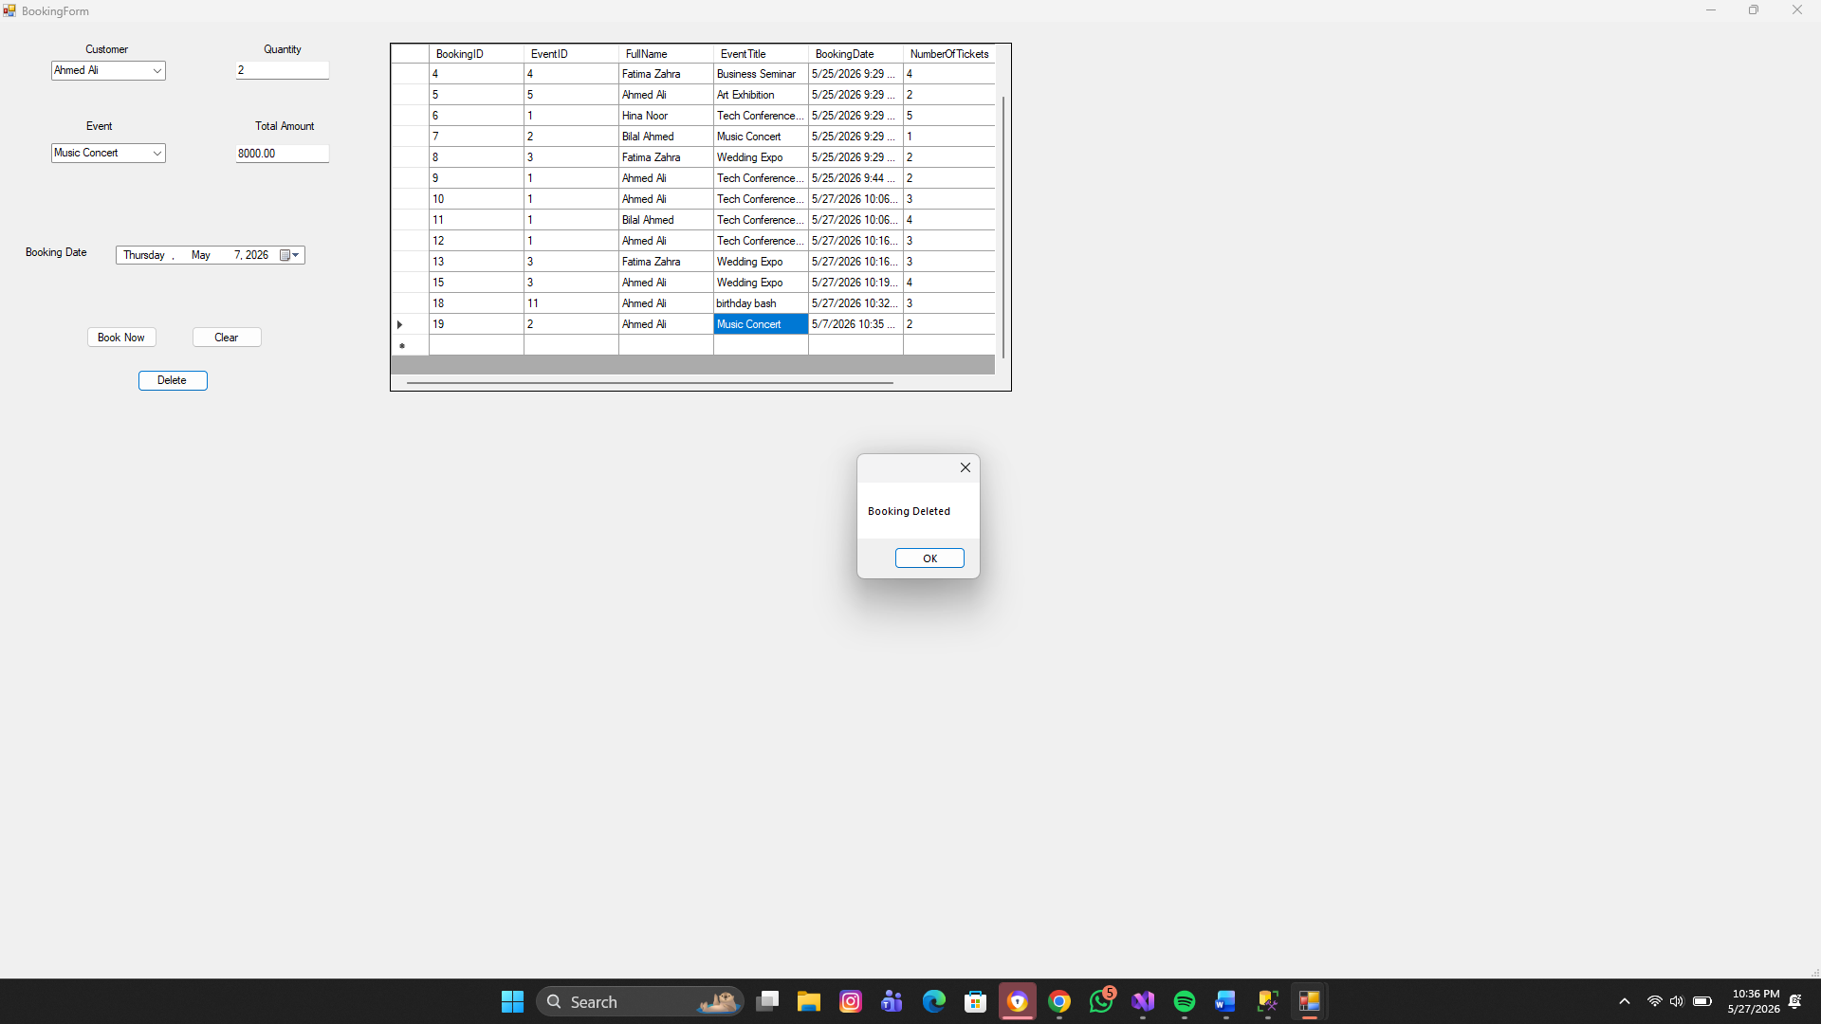
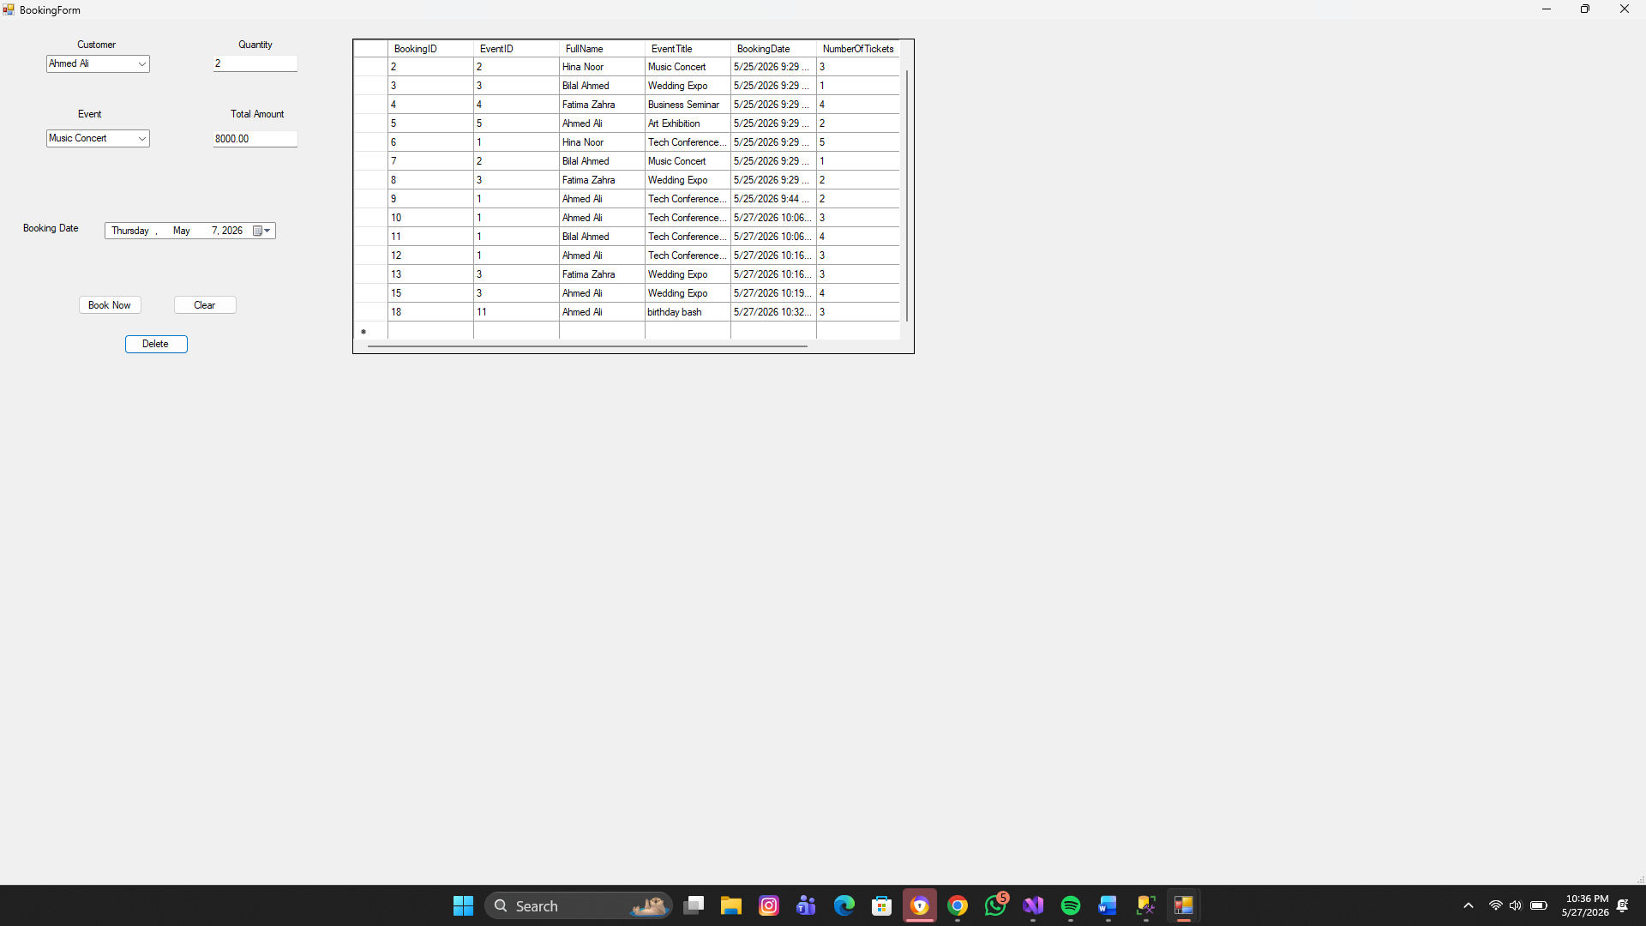
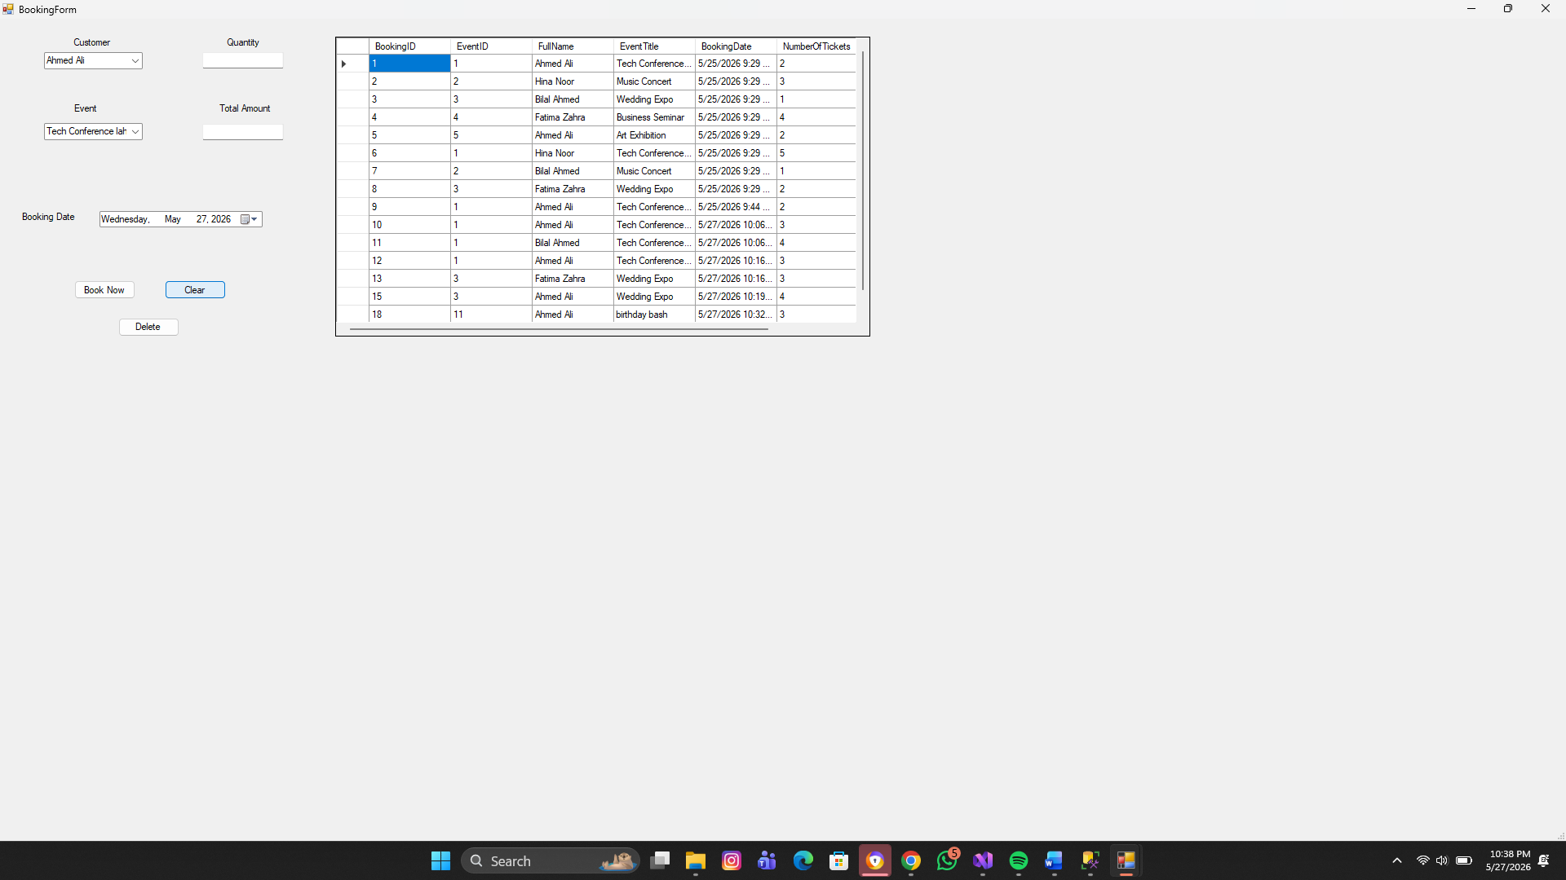

Payment Module
Features:
- Add payment
- Delete payment
- Display payment records
- Payment method handling
- Panel
Adding Payment:
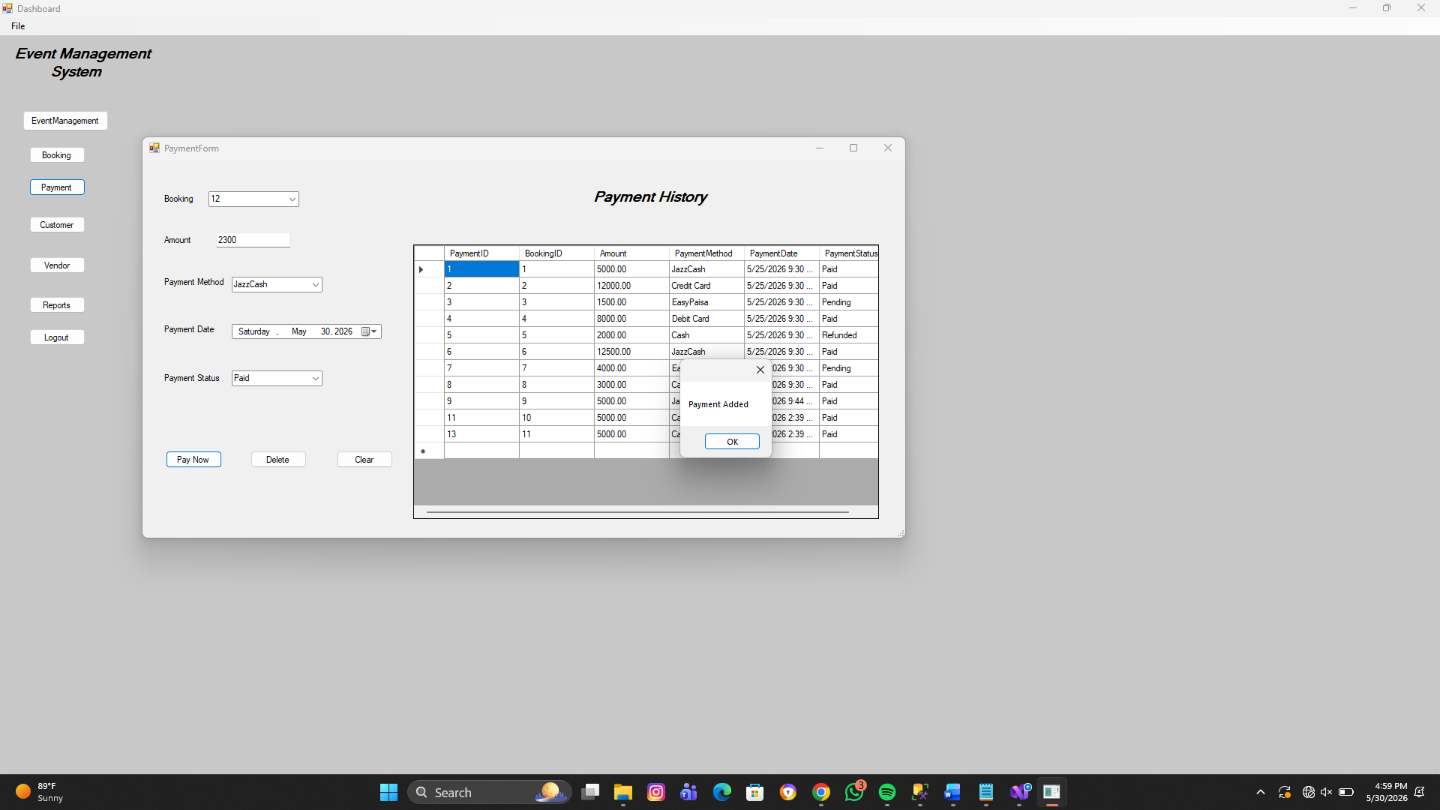

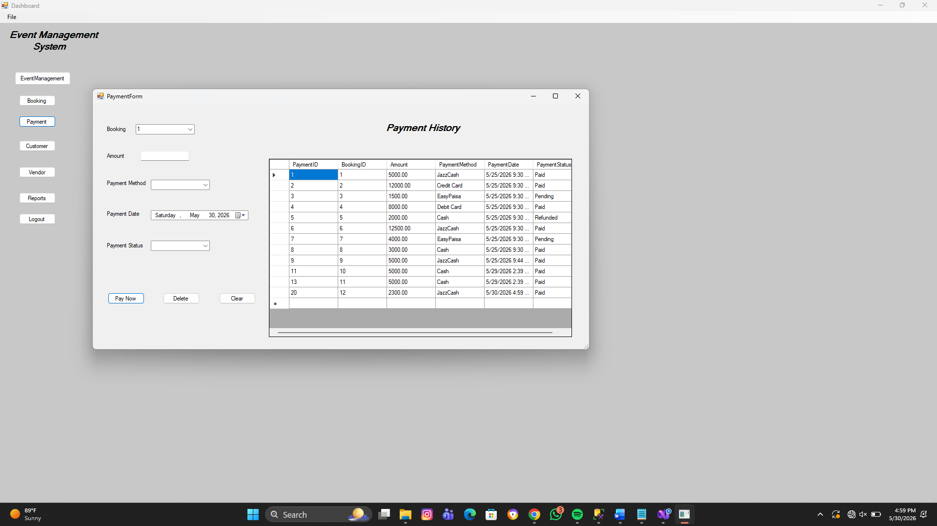

Deleting Payment:
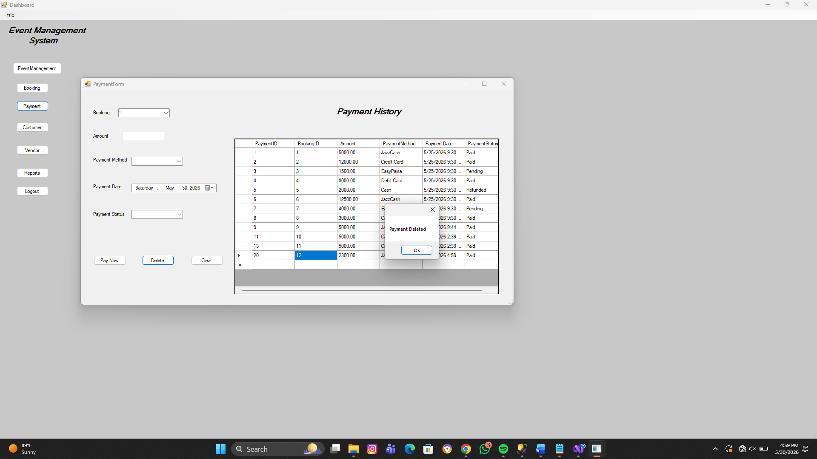
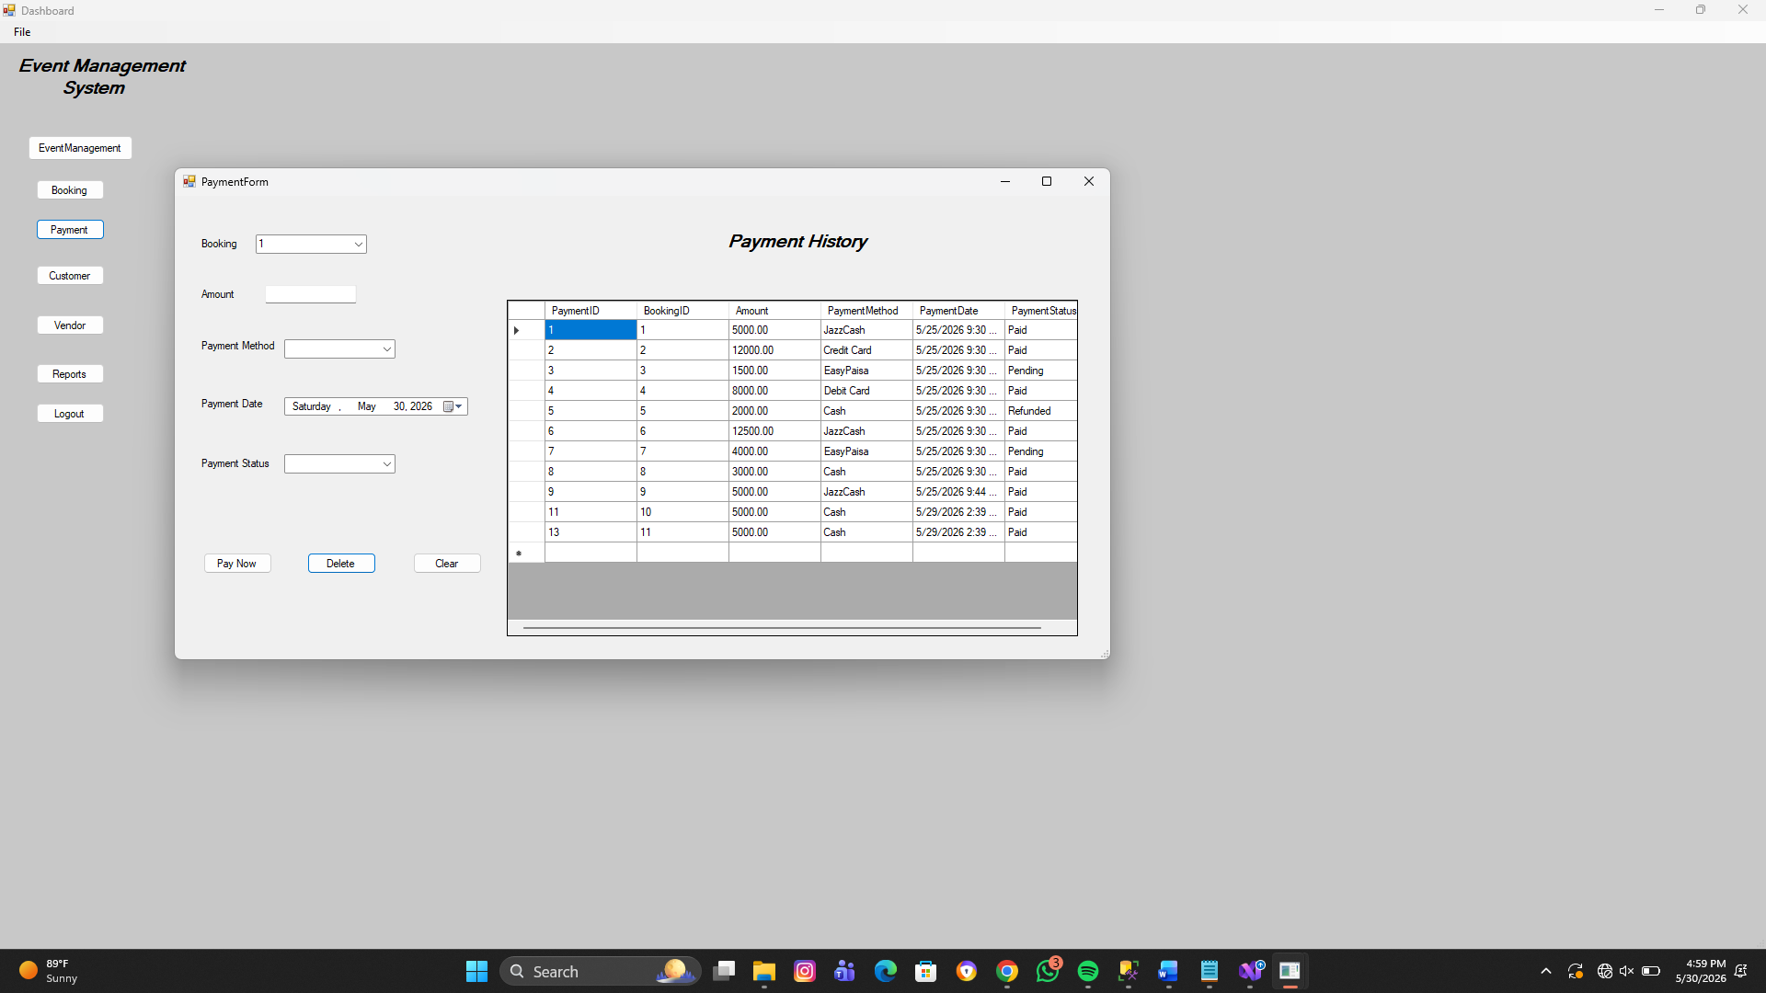

Customer Module
Features:
- Add customer
- Update customer
- Delete customer
- Search customer
- Gender selection using radio buttons
- Active status using checkbox
Customer table contains:
- CustomerID
- CustomerName
- Phone
- Gender
- Address
- IsActive
Adding Customers:
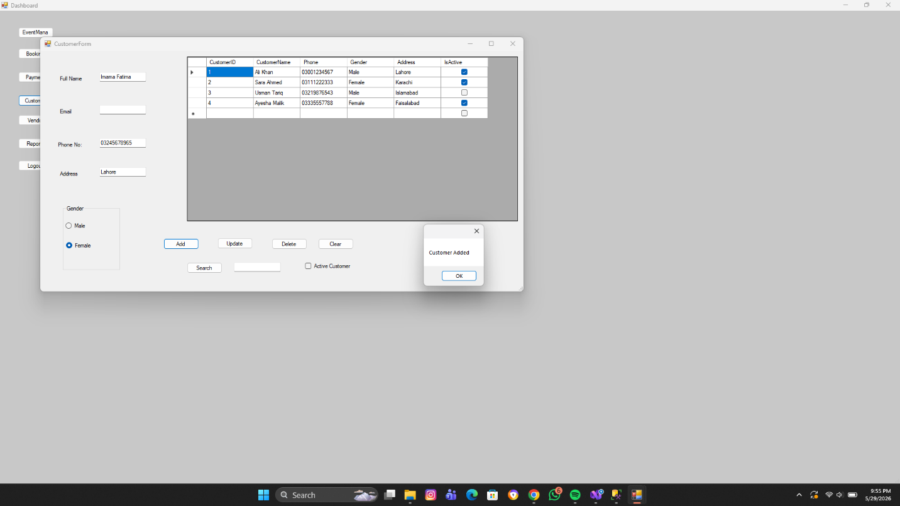
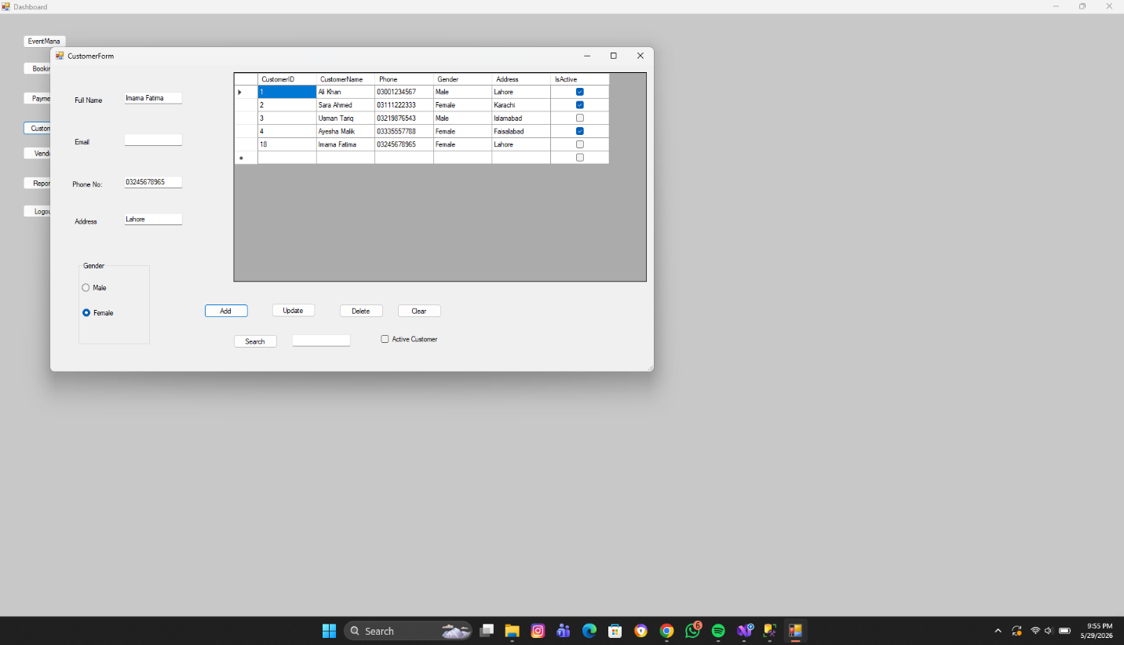
Deleting Customers:
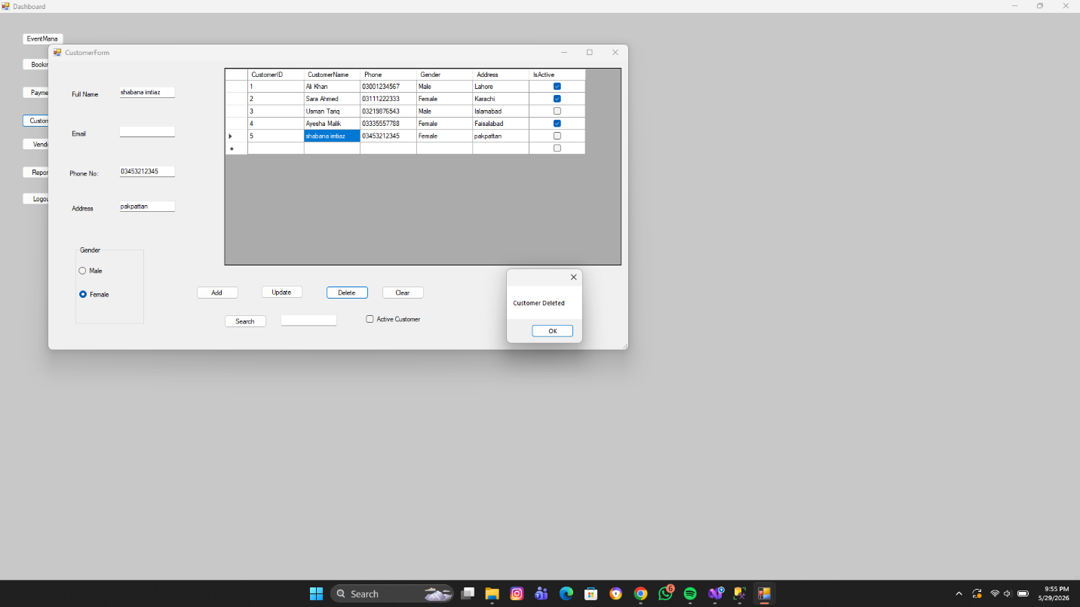
Vendor Module
Features:
- Add vendor
- Update vendor
- Delete vendor
- Search vendor
- Service type selection
Vendor table contains:
- VendorID
- VendorName
- Phone
- ServiceType

Adding Vendors:
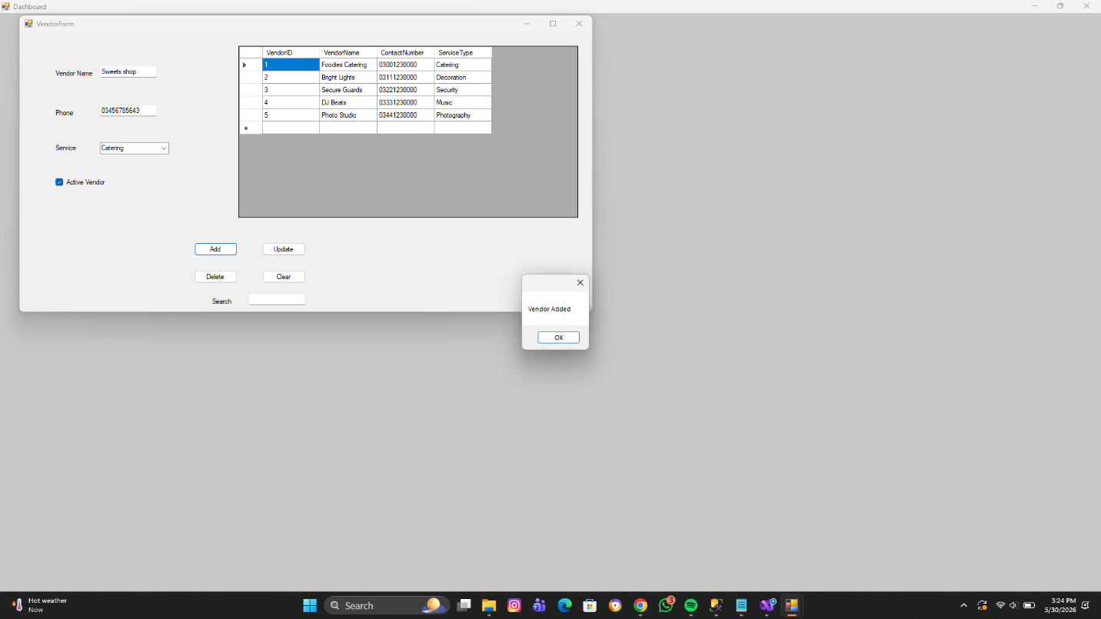

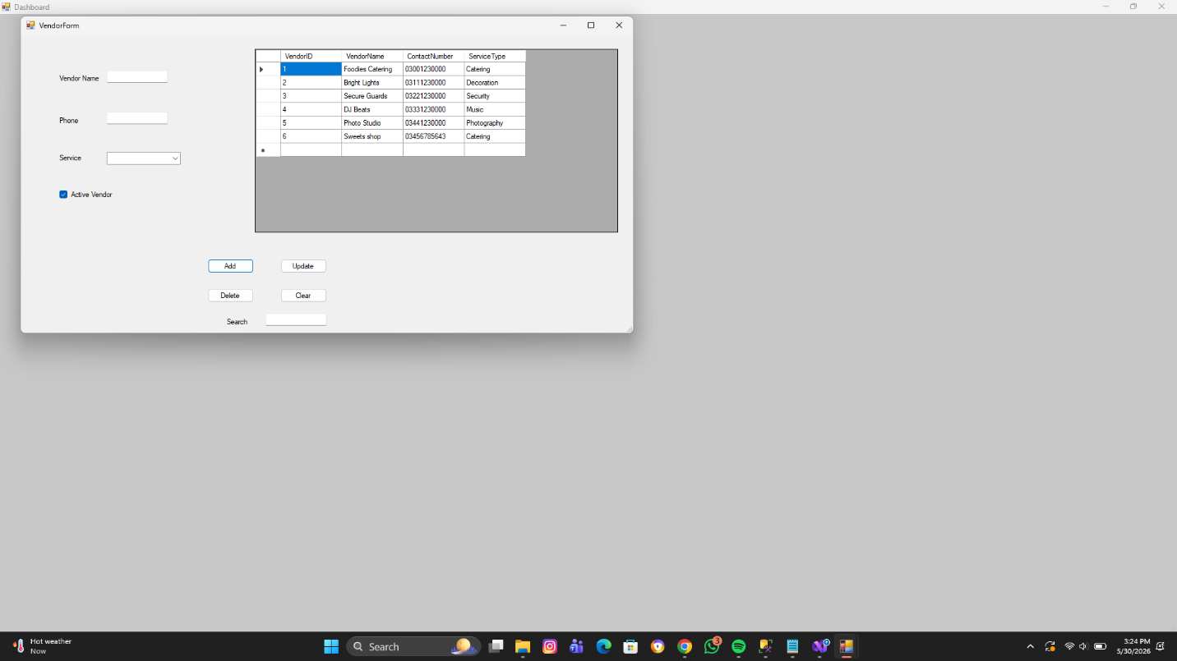

Updating vendors:

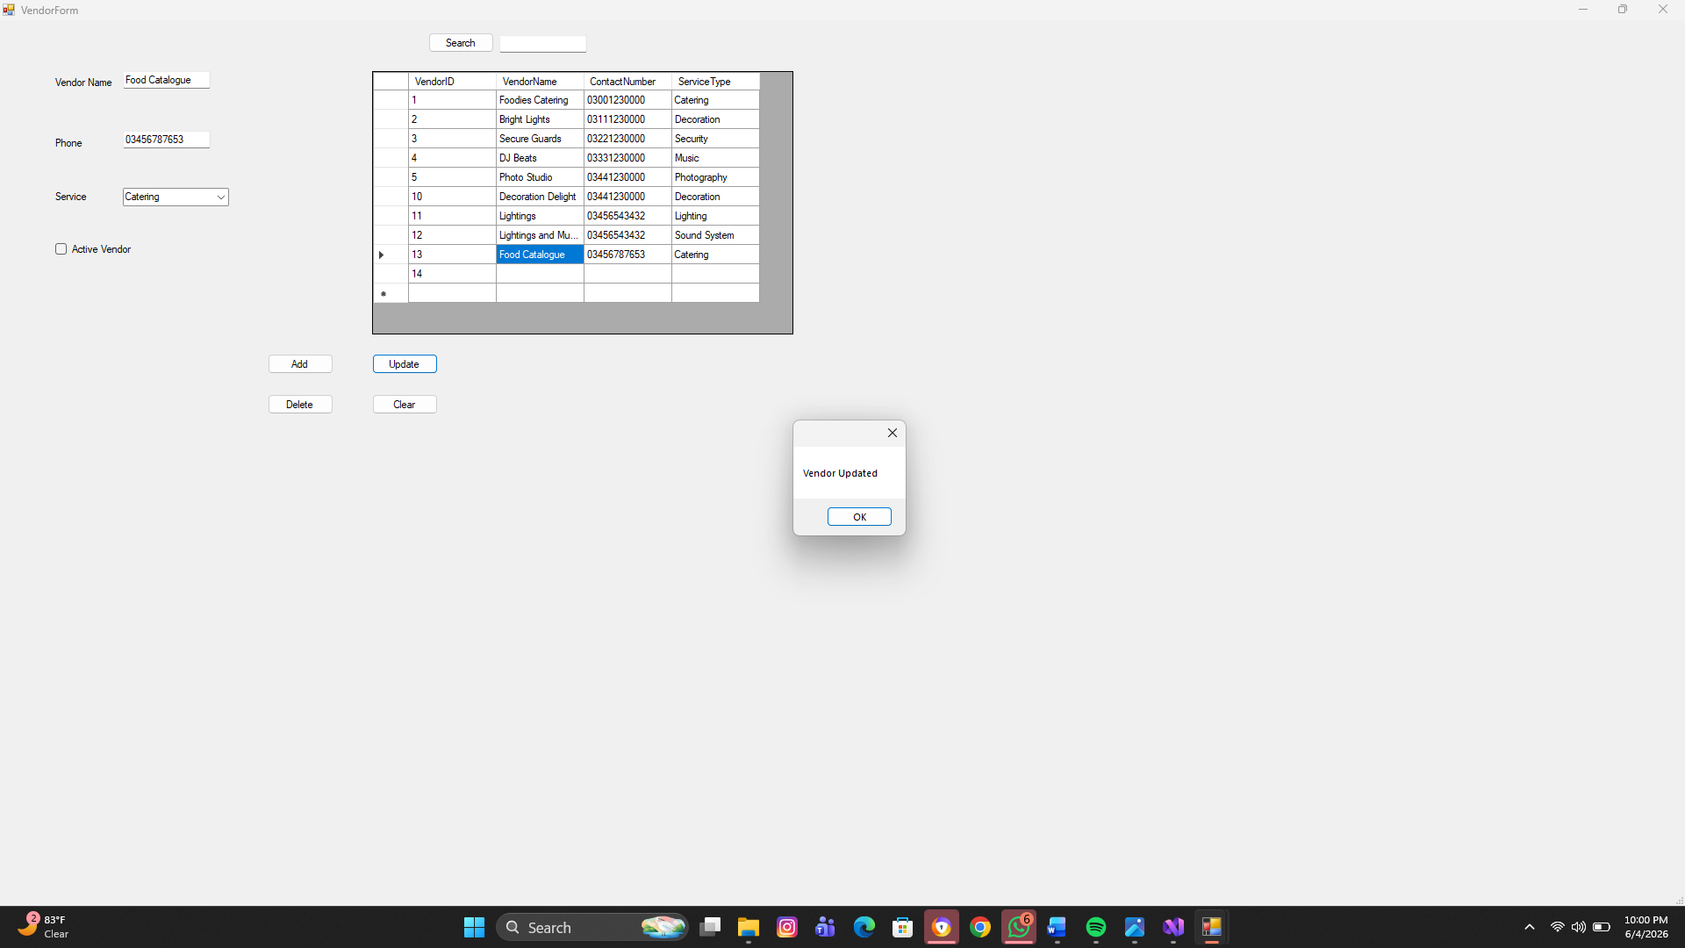
Searching from vendors:

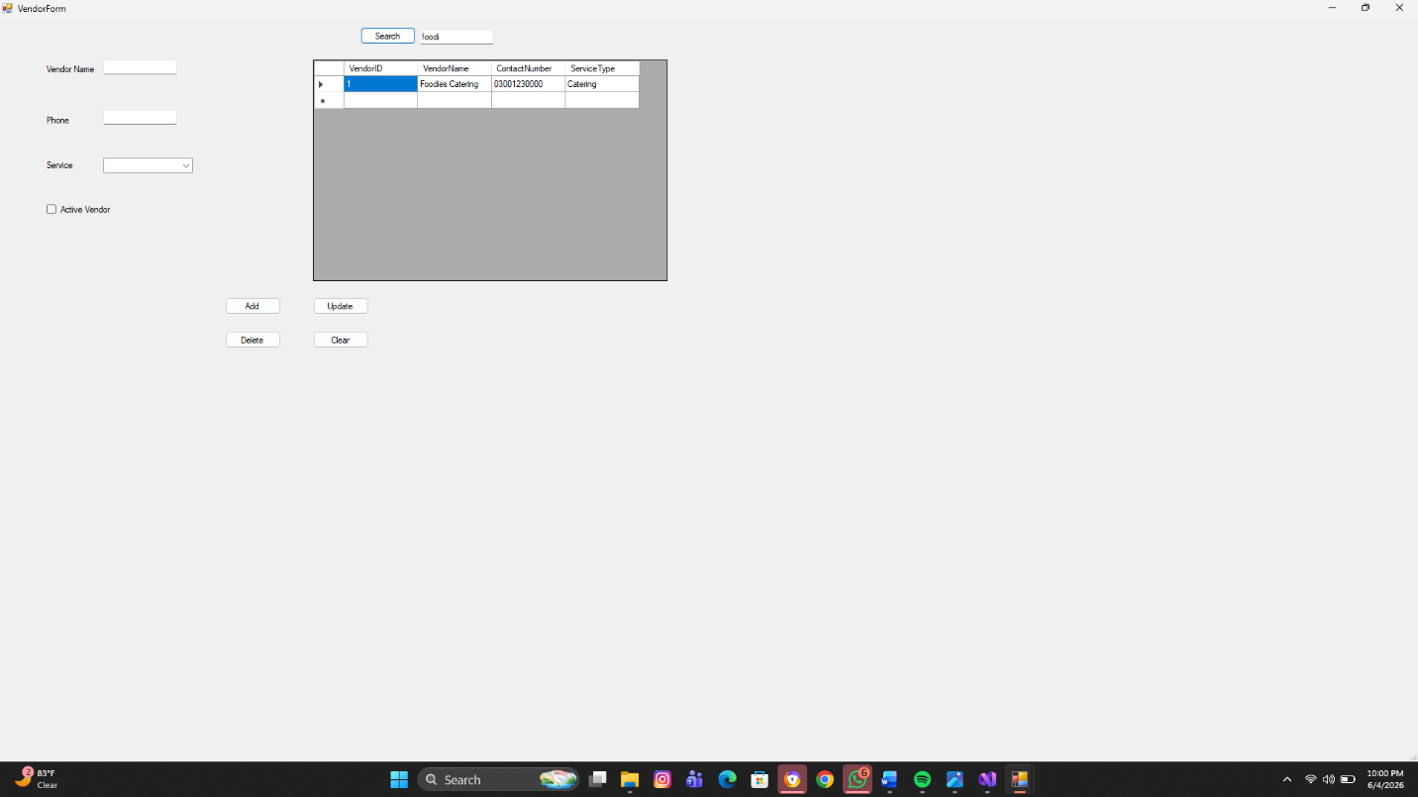

Venue Module:
- Store Venue Information
- Venue Capacity
- Contact etc
Adding Venue:
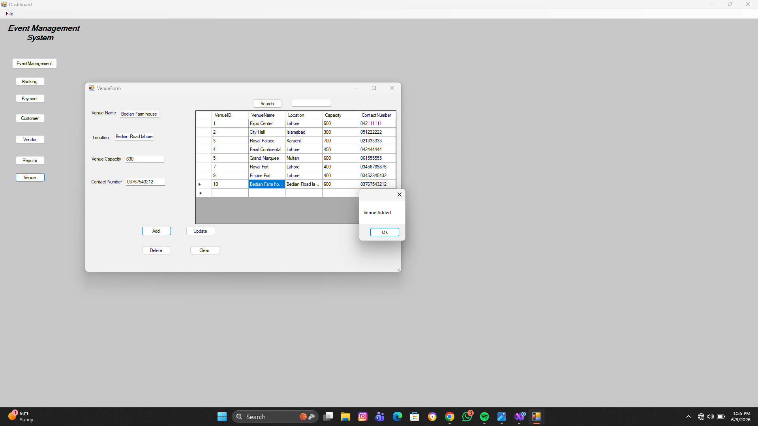
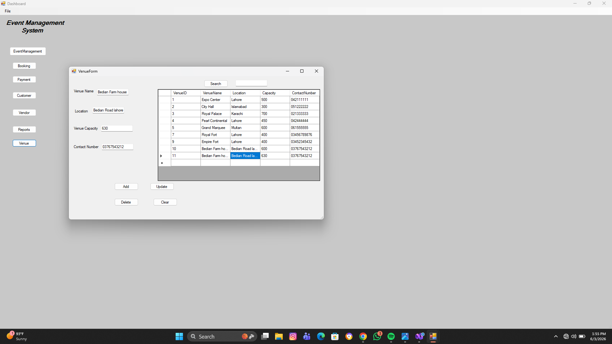

Updating Venue:
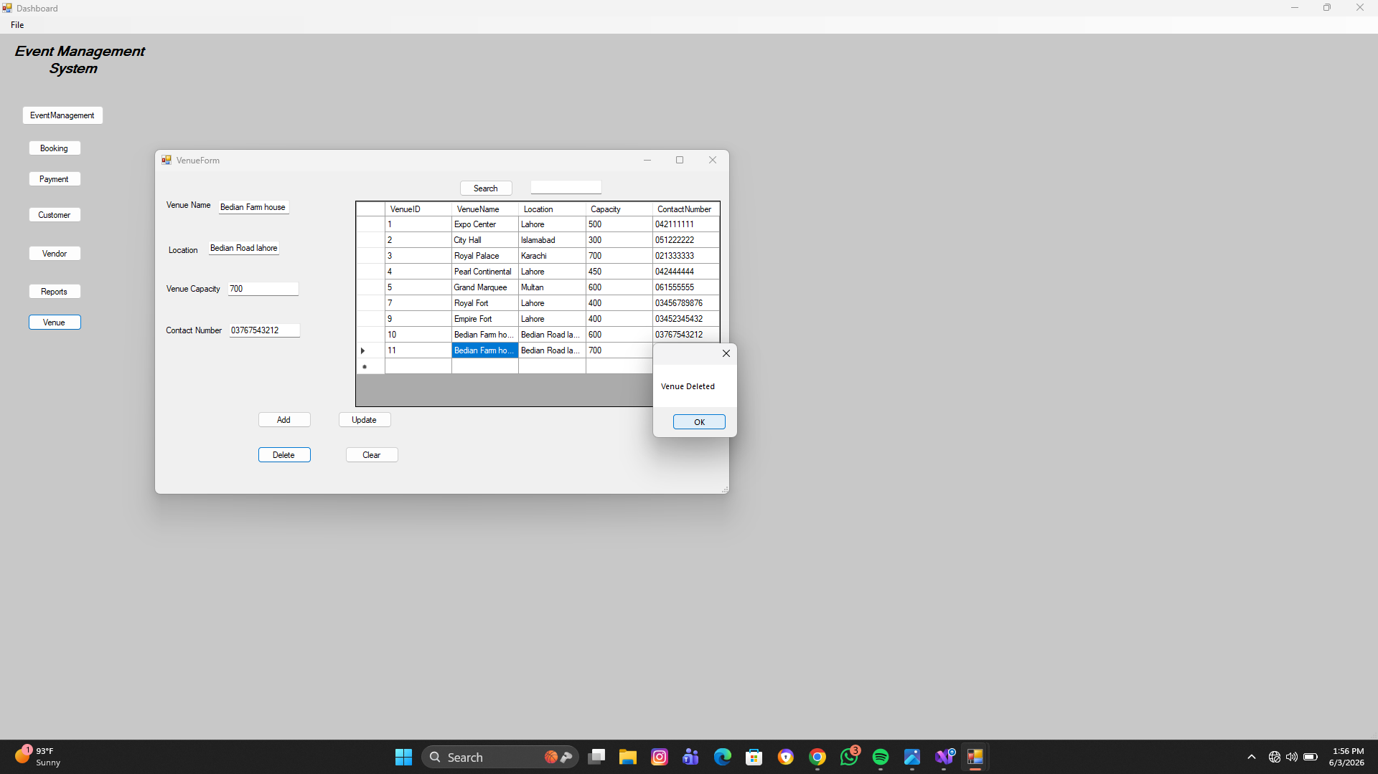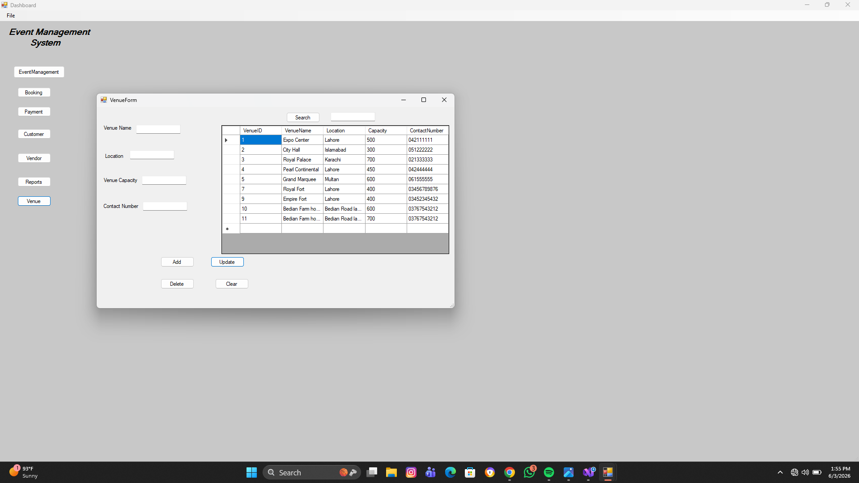

Deleting Venue:

Searching from Venue:
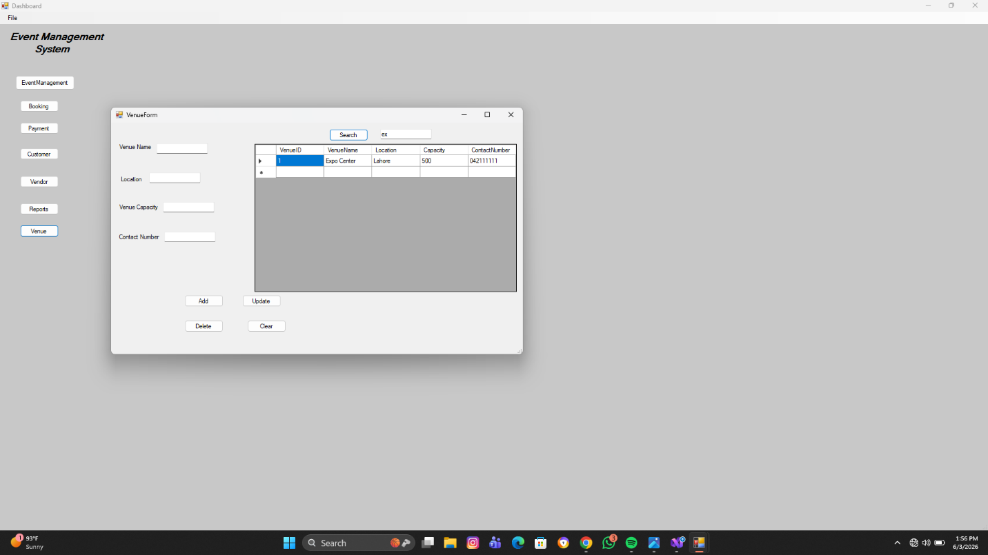
Reports Module
Features:
- Total Events
- Total Customers
- Total Bookings
- Total Payments
- Total Vendors
- Total Venues
- PDF Reports

Combo Box containing all reports:

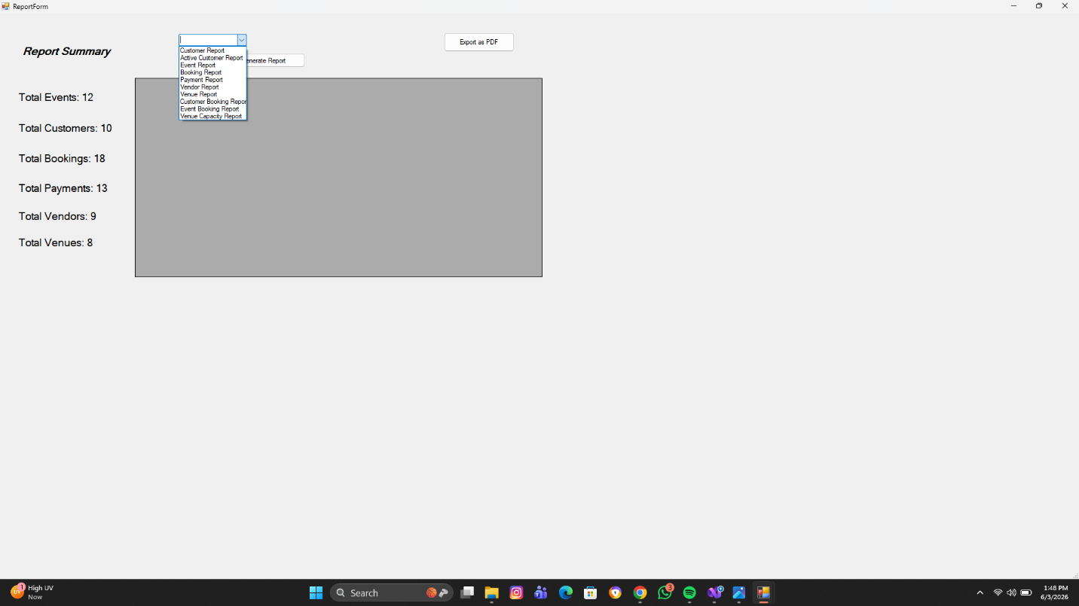

Customer report:

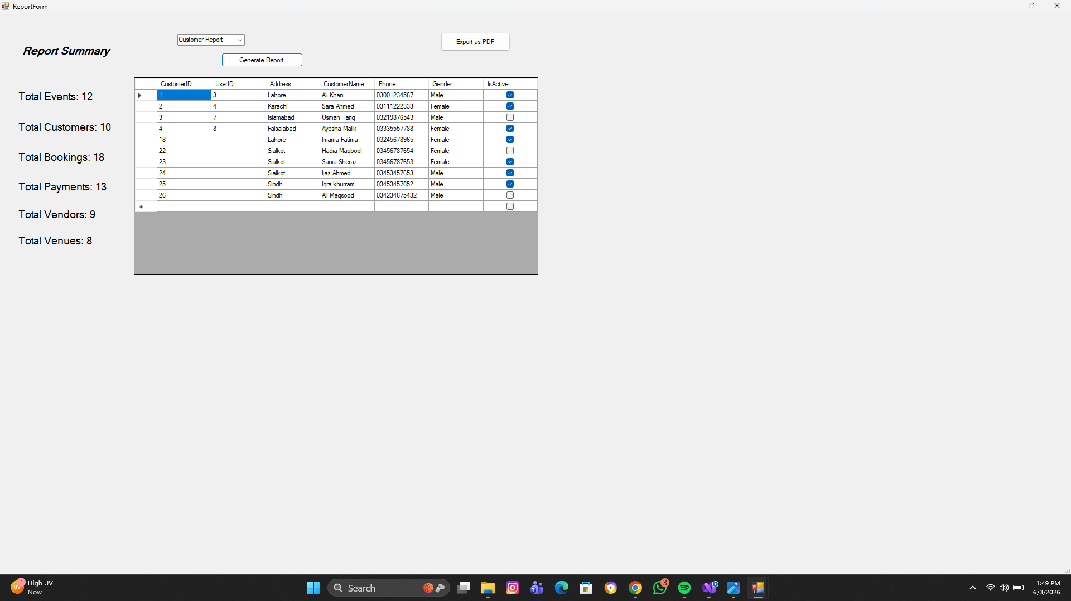

Active Customer report:

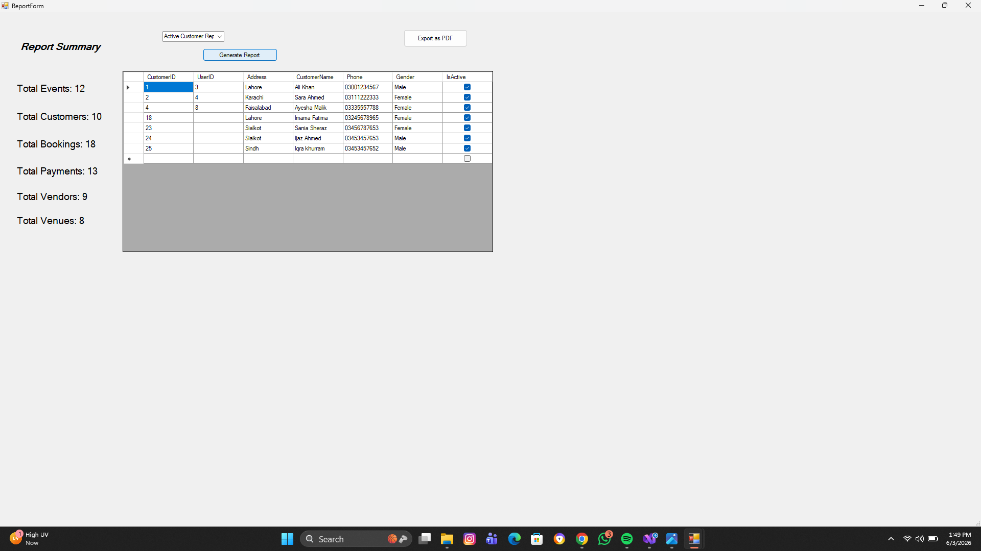

Event Report:

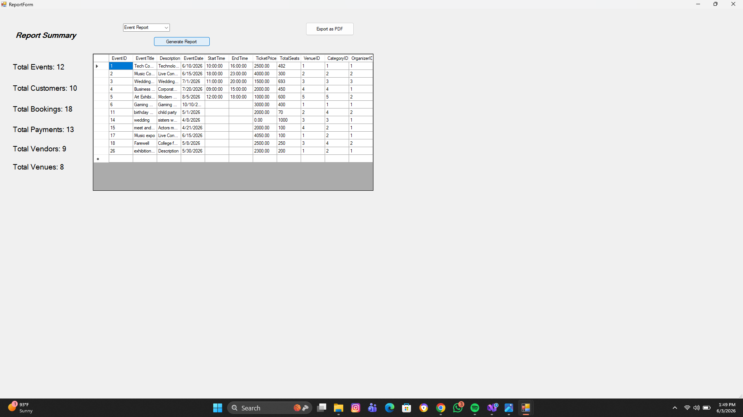

Booking report:

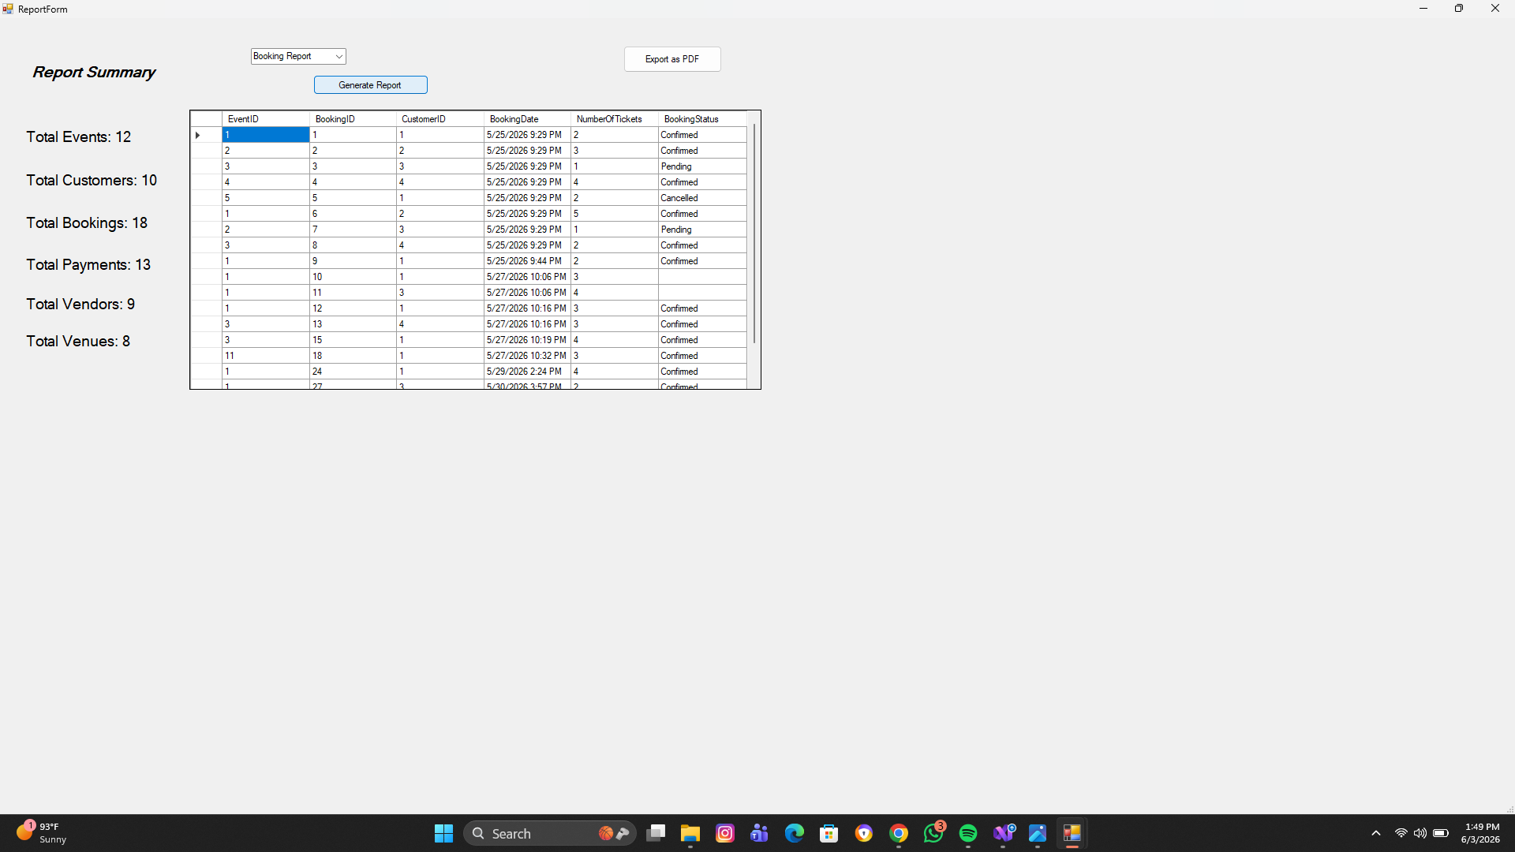

Payment report:

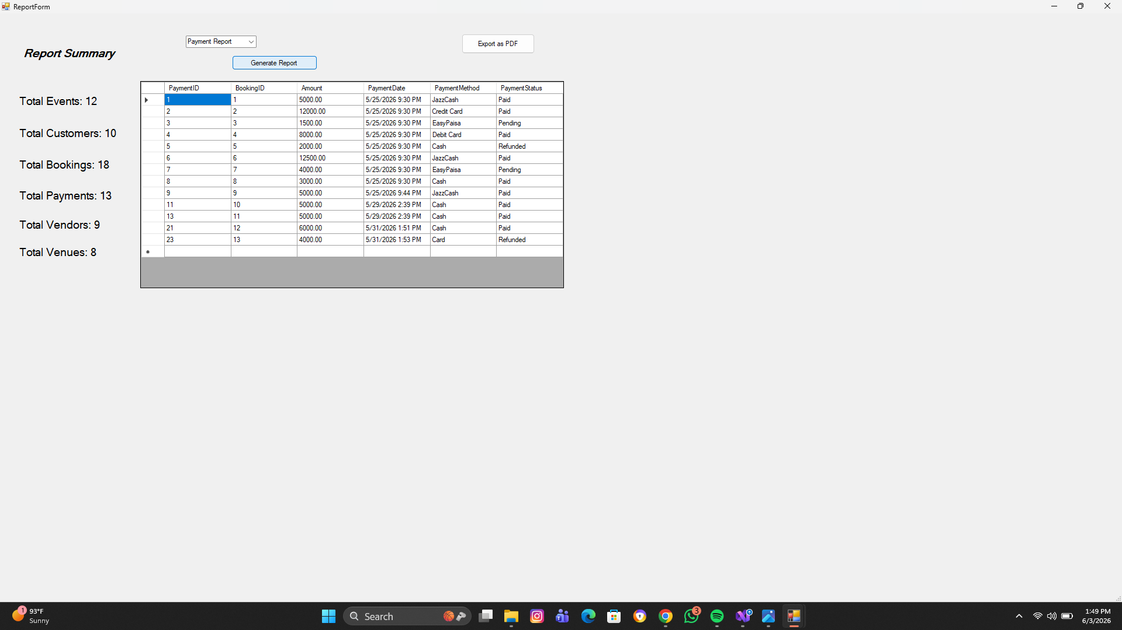

Vendor report:

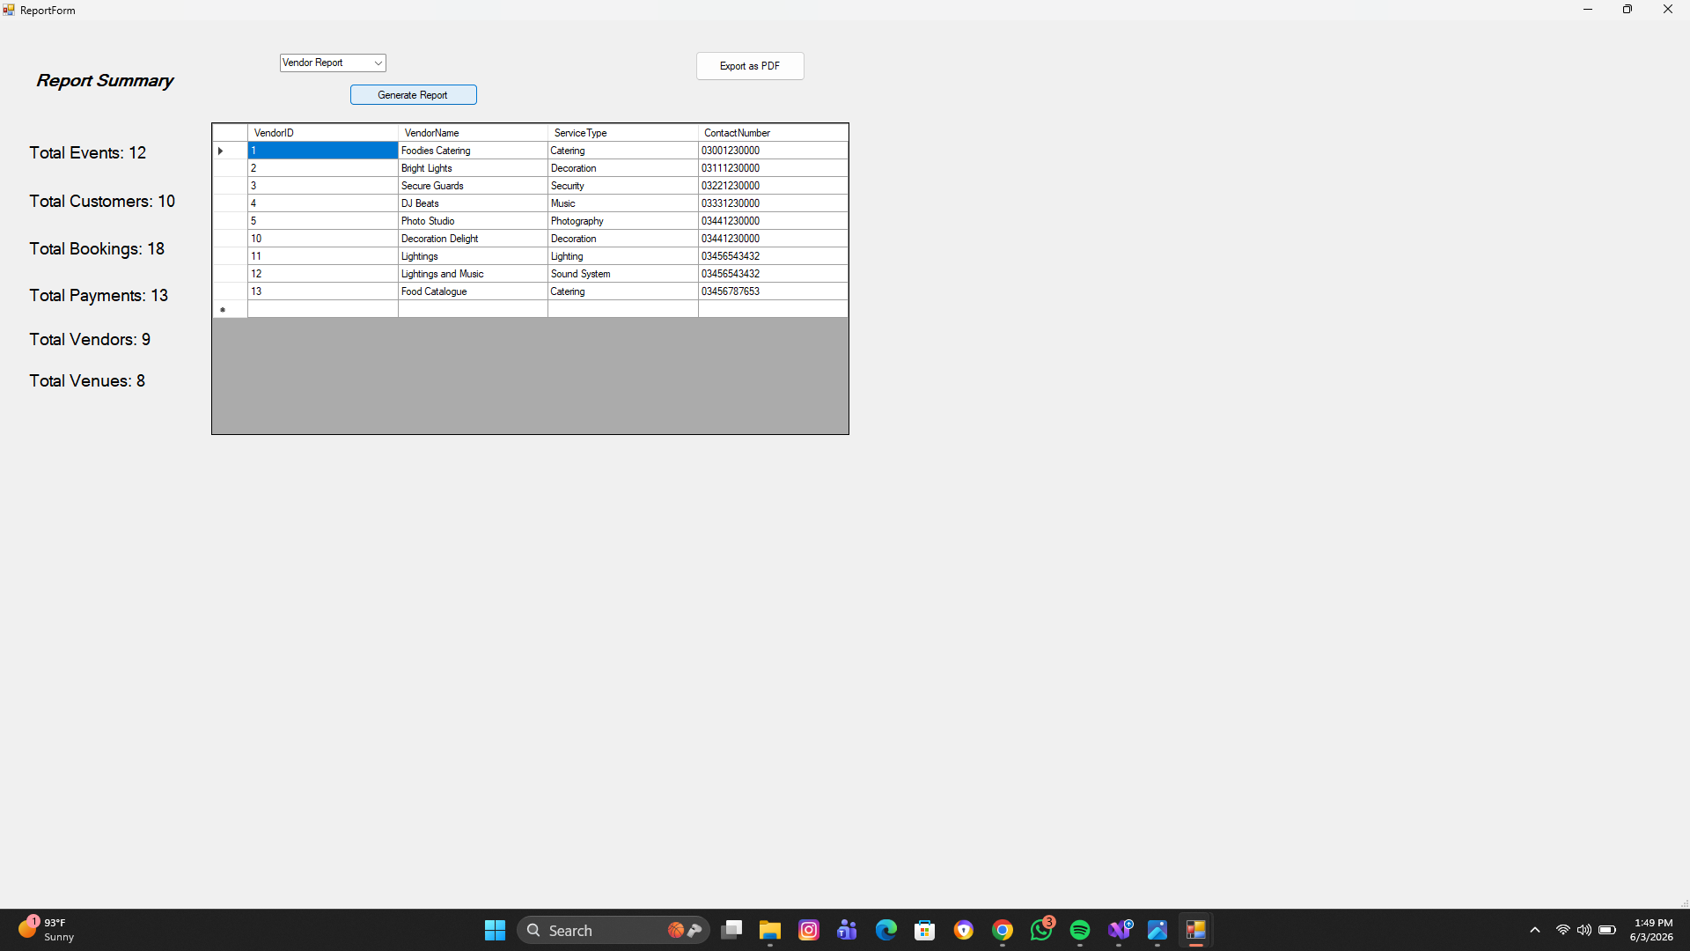
Venue report:

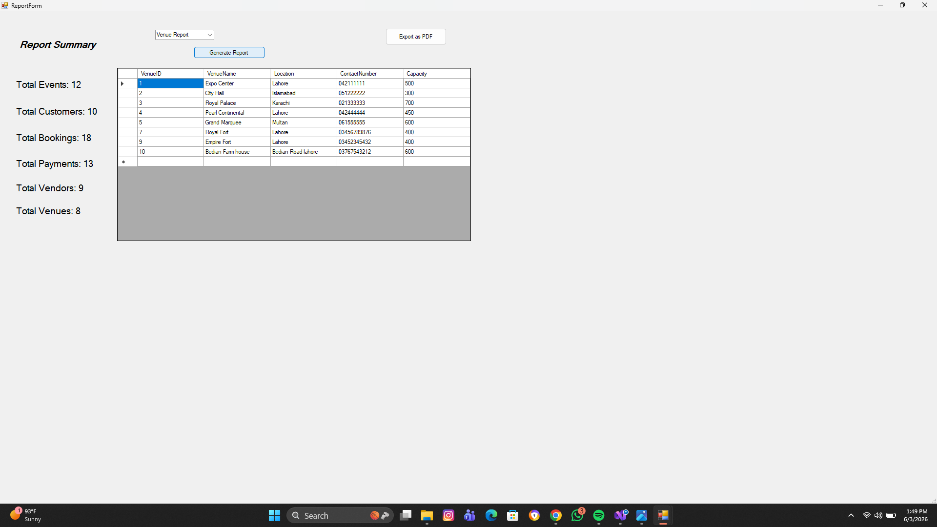

Customer booking report:

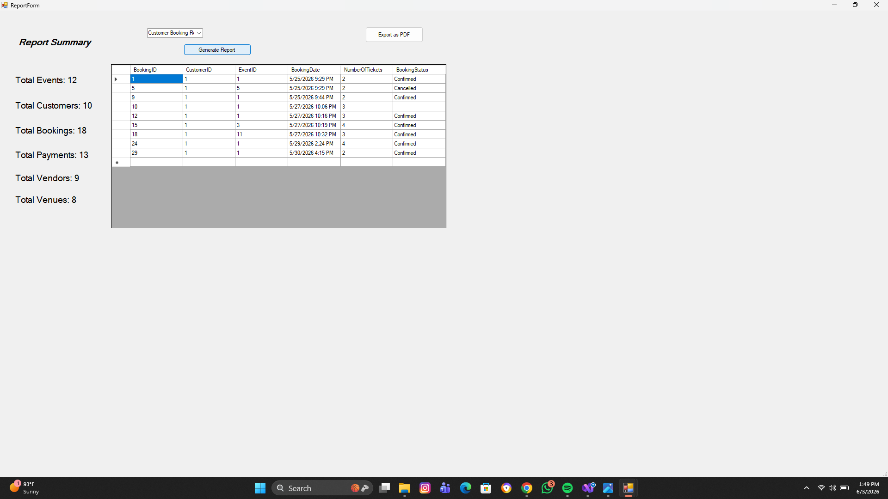
Event booking report:
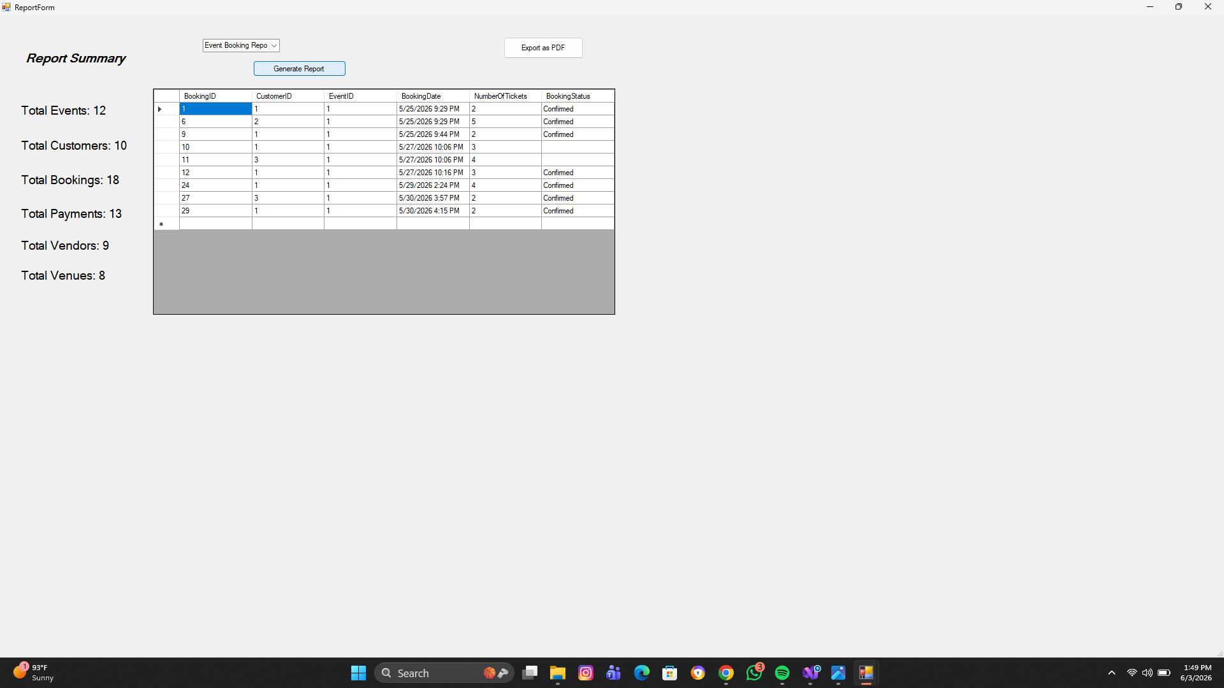

Venue Capacity report:

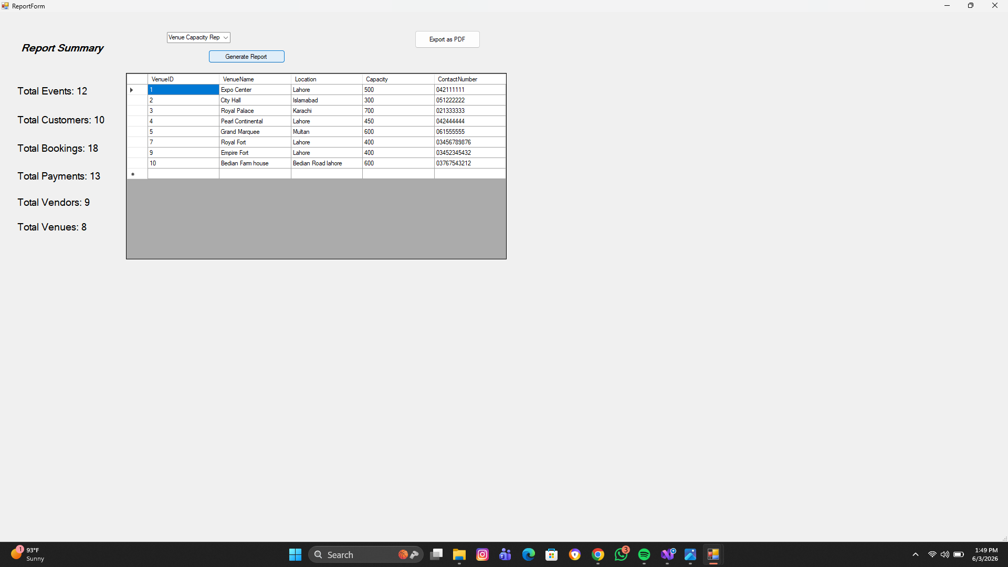
Exporting Reports as pdf:

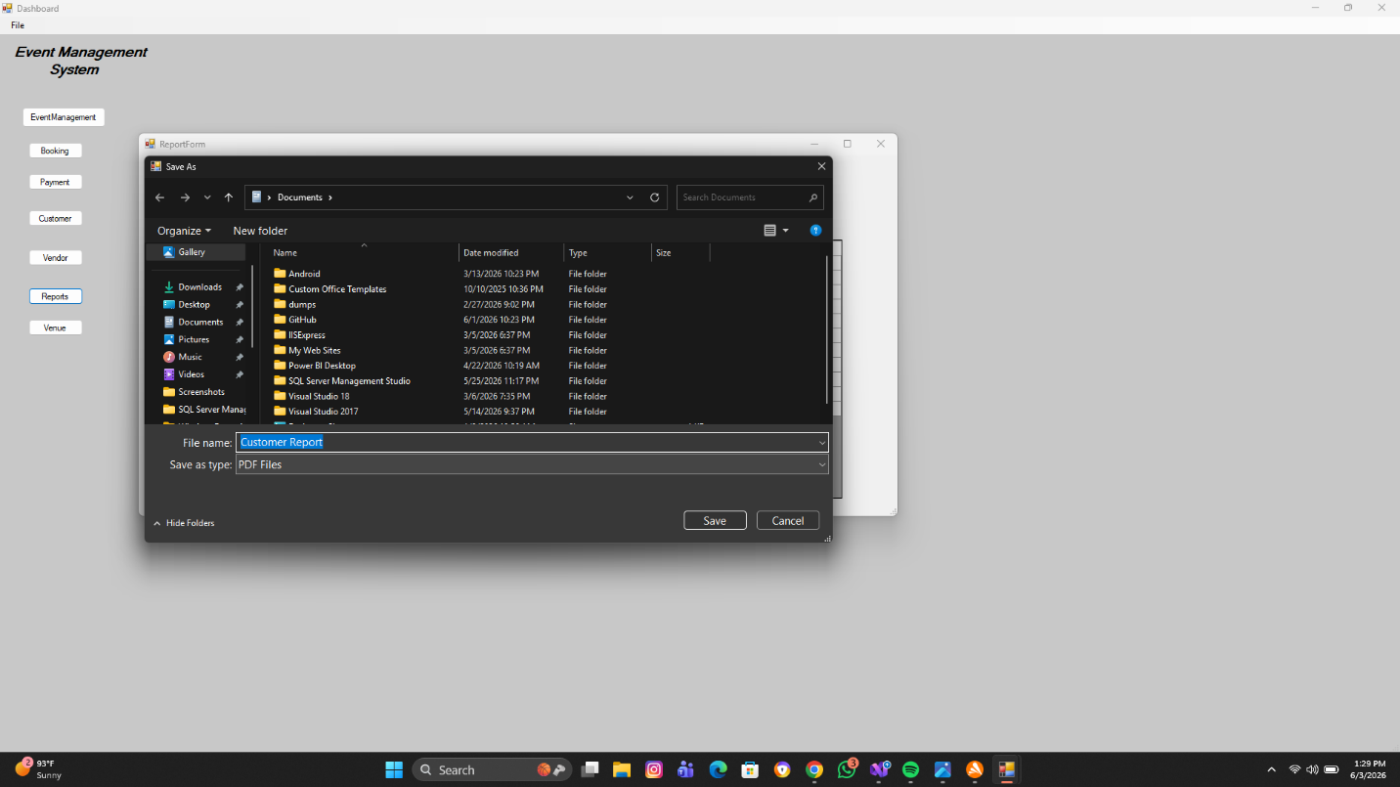
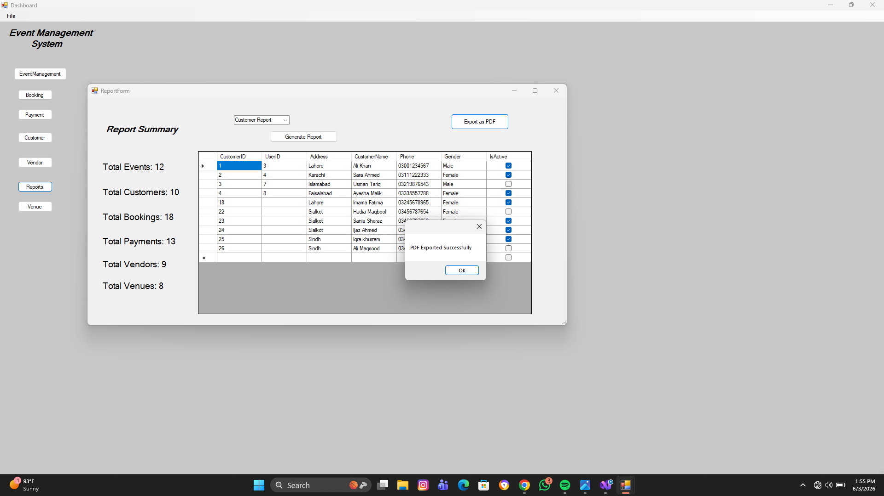

Logout Module:
- Logout of the system

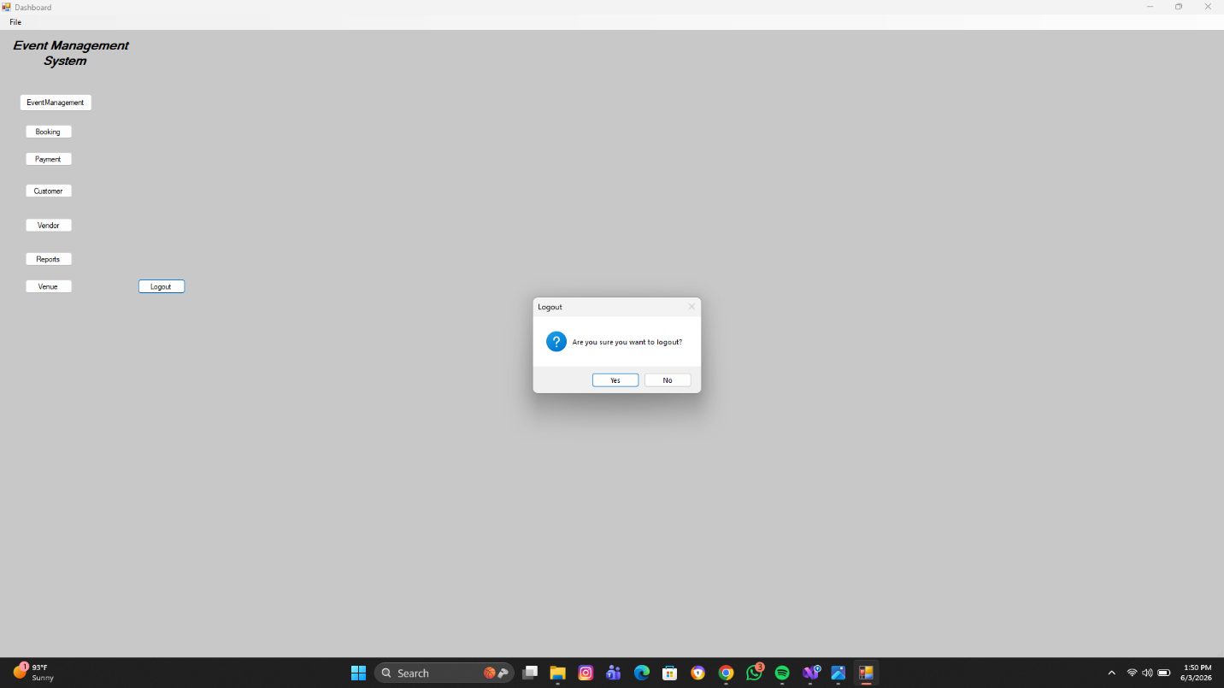

Database Tables

User Table
Stores admin/faculty login information.

Customer Table
Stores customer information for bookings.

Event Table
Stores event details.

Booking Table
Stores booking records.

Payment Table
Stores payment information.

Vendor Table
Stores vendor information.

Venue Table
Stores venue information.

PDF Business Level Reports
- Used itextsharp
- Business level report queries are exportable as a PDF

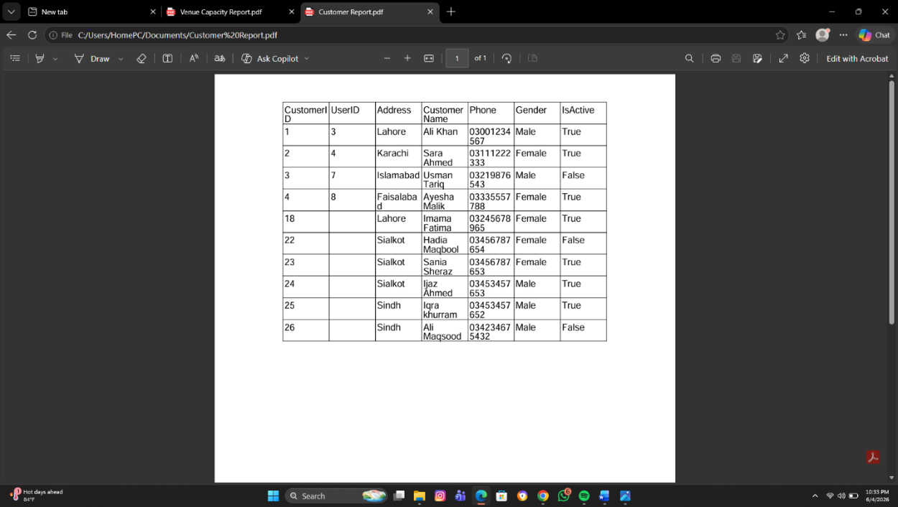

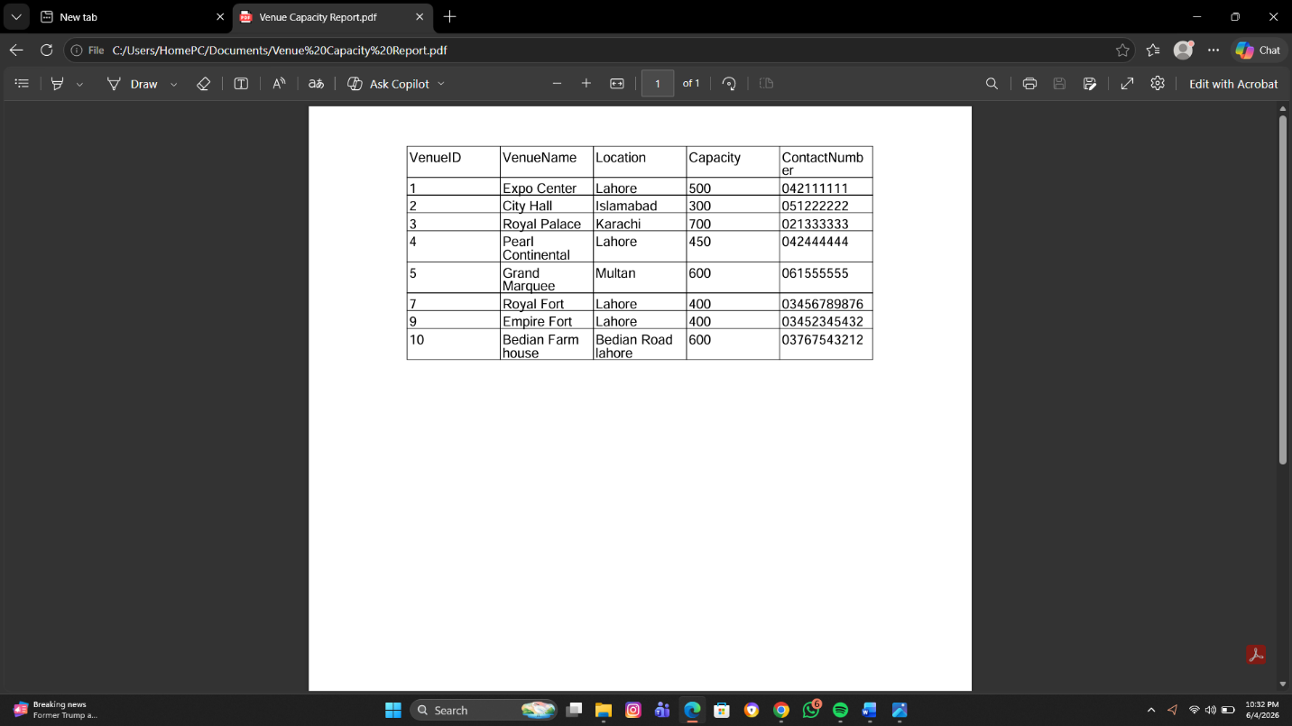

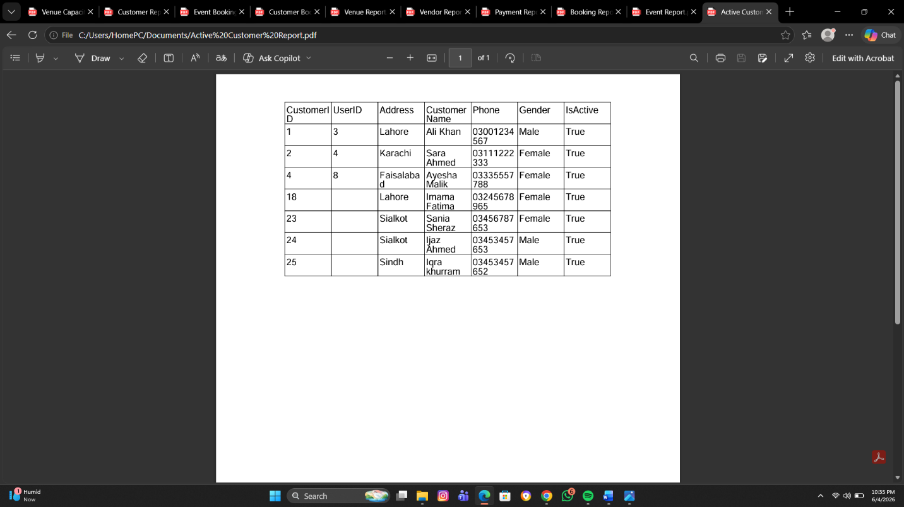

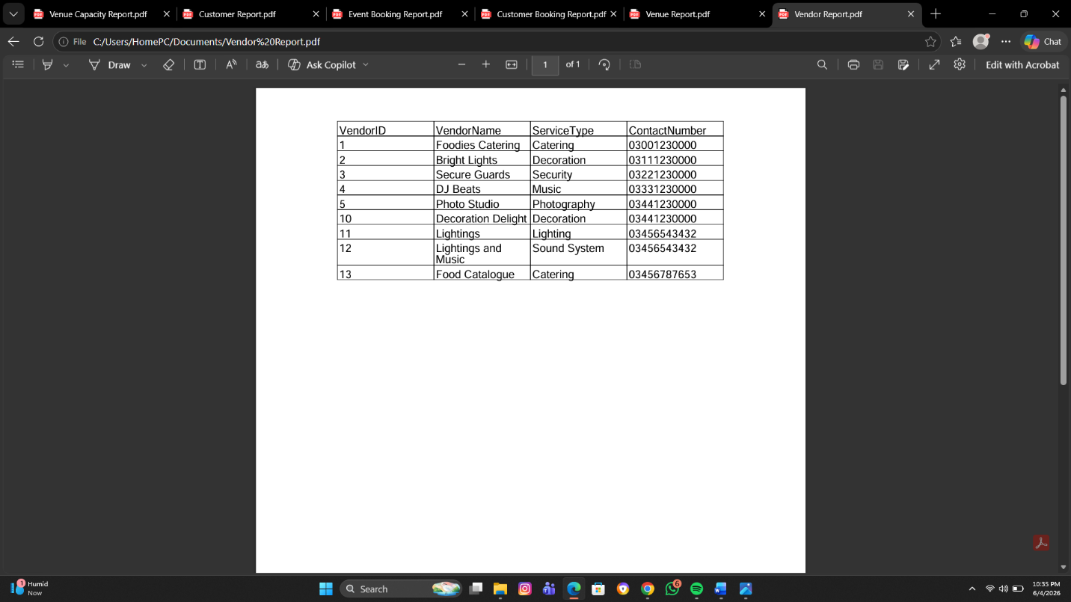

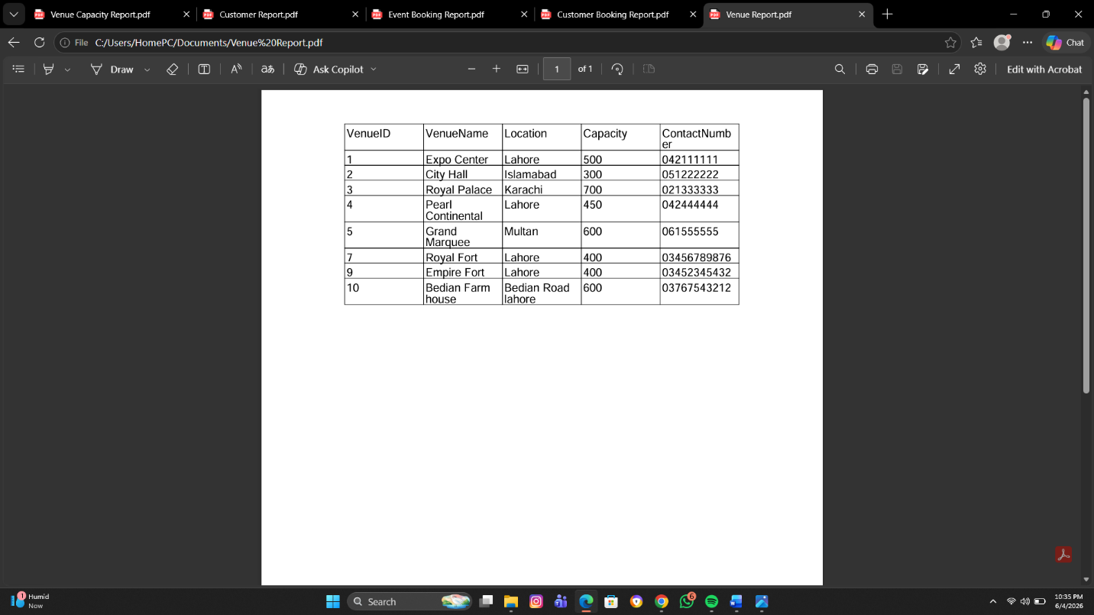
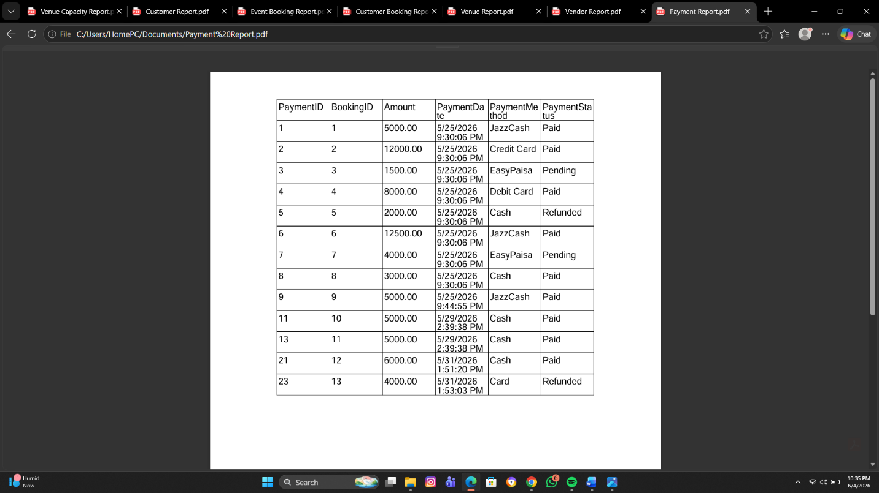
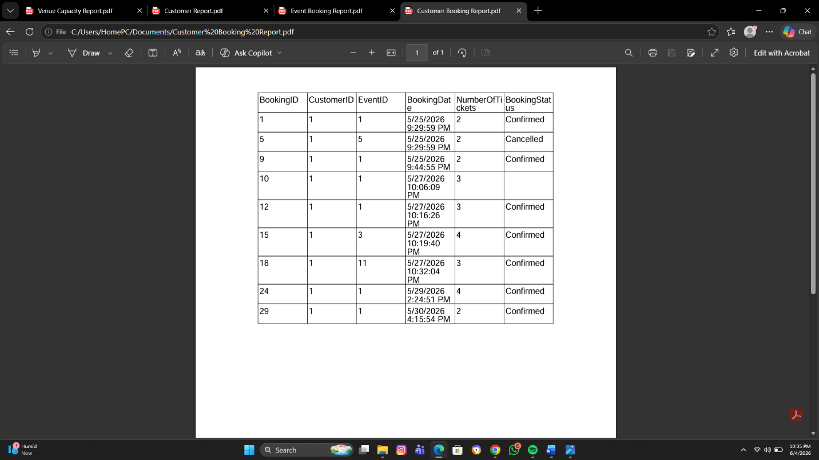
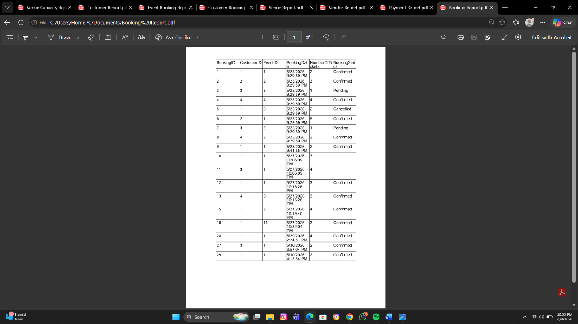
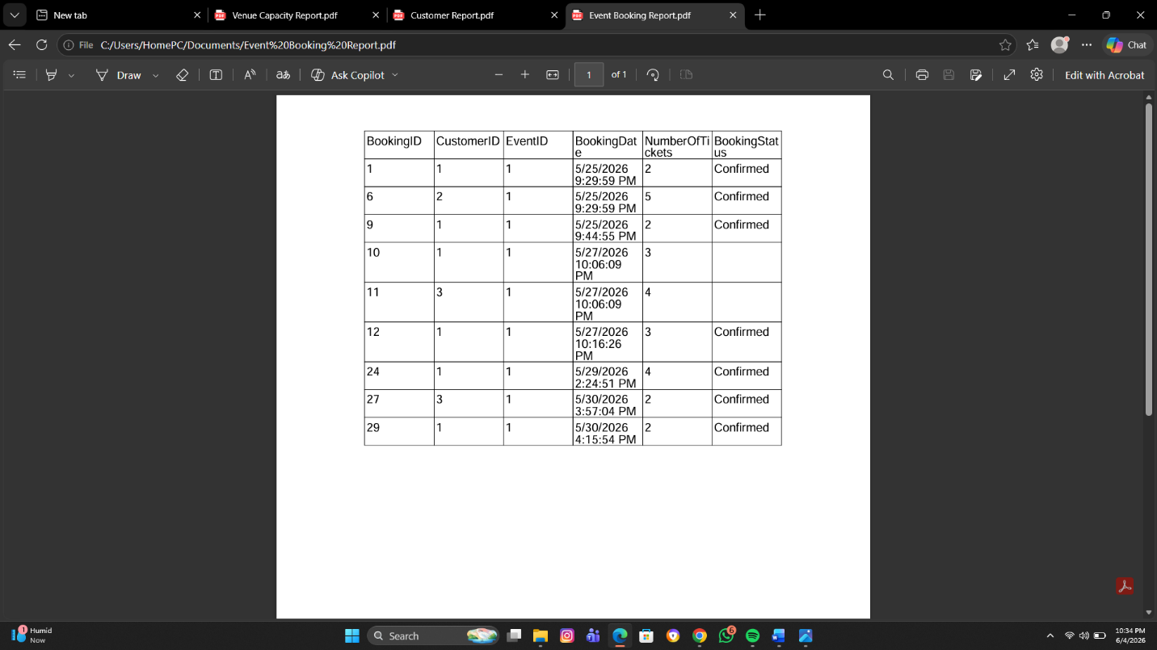
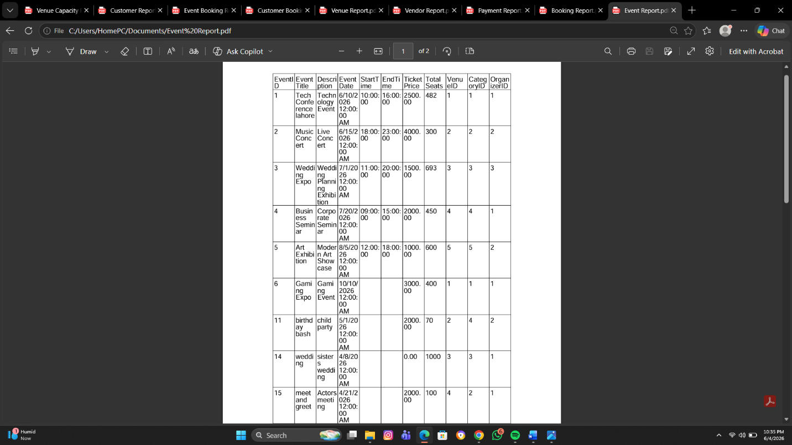

Concepts Used
- Primary Keys
- Foreign Keys
- CRUD Operations
- SQL Queries
- Parameterized Queries
- DataGridView
- ComboBox
- RadioButton
- CheckBox
- Panels
- MenuStrip
- Exception Handling
- Exception Handling
- Validation
- Report Manager
- Database Connectivity

Advantages of the System
- Reduces manual work
- Improves data management
- Fast event handling
- Easy booking management
- User-friendly interface
- Secure login system

Conclusion
The Event Management System successfully manages events, customers, bookings, payments, vendors, and venues using SQL Server and Windows Forms. The project demonstrates database connectivity, CRUD operations, relationships, and GUI development effectively.

